Temasek Polytechnic

School of Informatics and IT

**Diploma in Information Technology (IT)**

Software Design Specifications (DS)

**Project Particulars**

|  |  |
| --- | --- |
| **Tutor** | Mr Mel Goh |
| **Class** | P01 |
| **Project Title** | Delonix Regia Hotel Management System |

**Project Team’s Particulars**

|  |  |
| --- | --- |
| **Matric Number** | **Student Name** |
| **1500826A** | **Muhammad Faiz Bin Kamaruddin** |
| **1506522J** | **Ang Wei Xiang** |
| **1502868A** | **Thien Yun Kai** |
| **1506657D** | **Darren Teo Wei Wen** |

Revision History

|  |  |  |  |
| --- | --- | --- | --- |
| **Date** | **Version** | **Description** | **Author** |
| <dd/mm/yy> | <x.x> | <details> | <name> |
|  |  |  |  |
|  |  |  |  |
|  |  |  |  |

**Table of Contents**

1. DISTRIBUTION OF WORKLOAD.. 4

2. ARCHITECTURE DESIGN.. 4

3. USER INTERFACE (UI) DESIGN.. 4

4. PROGRAM DESIGN.. 4

5. DATABASE DESIGN.. 4

# 

# 

# 

# 

# **1.** **DISTRIBUTION OF WORKLOAD**

# 

*[Determine which members of the team will be responsible for which areas of design. Individual’s responsibilities should be clearly spelt out.]*

|  |  |
| --- | --- |
| **Design** | **Members** |
| Architecture Design, Program Design | Muhammad Faiz Bin Kamaruddin |
| Architecture Design, Program Design | Ang Wei Xiang |
| User Interface Design | Thein Yun Kai |
| Database Design | Darren Teo Wei Wen |

# 

# **2.** **ARCHITECTURE DESIGN**

*[Describe the proposed system architecture design e.g. 2-tier comprising of client-data? Or 3-tier comprising of client-business-data? Include diagram to illustrate the different tiers in the architecture.]*

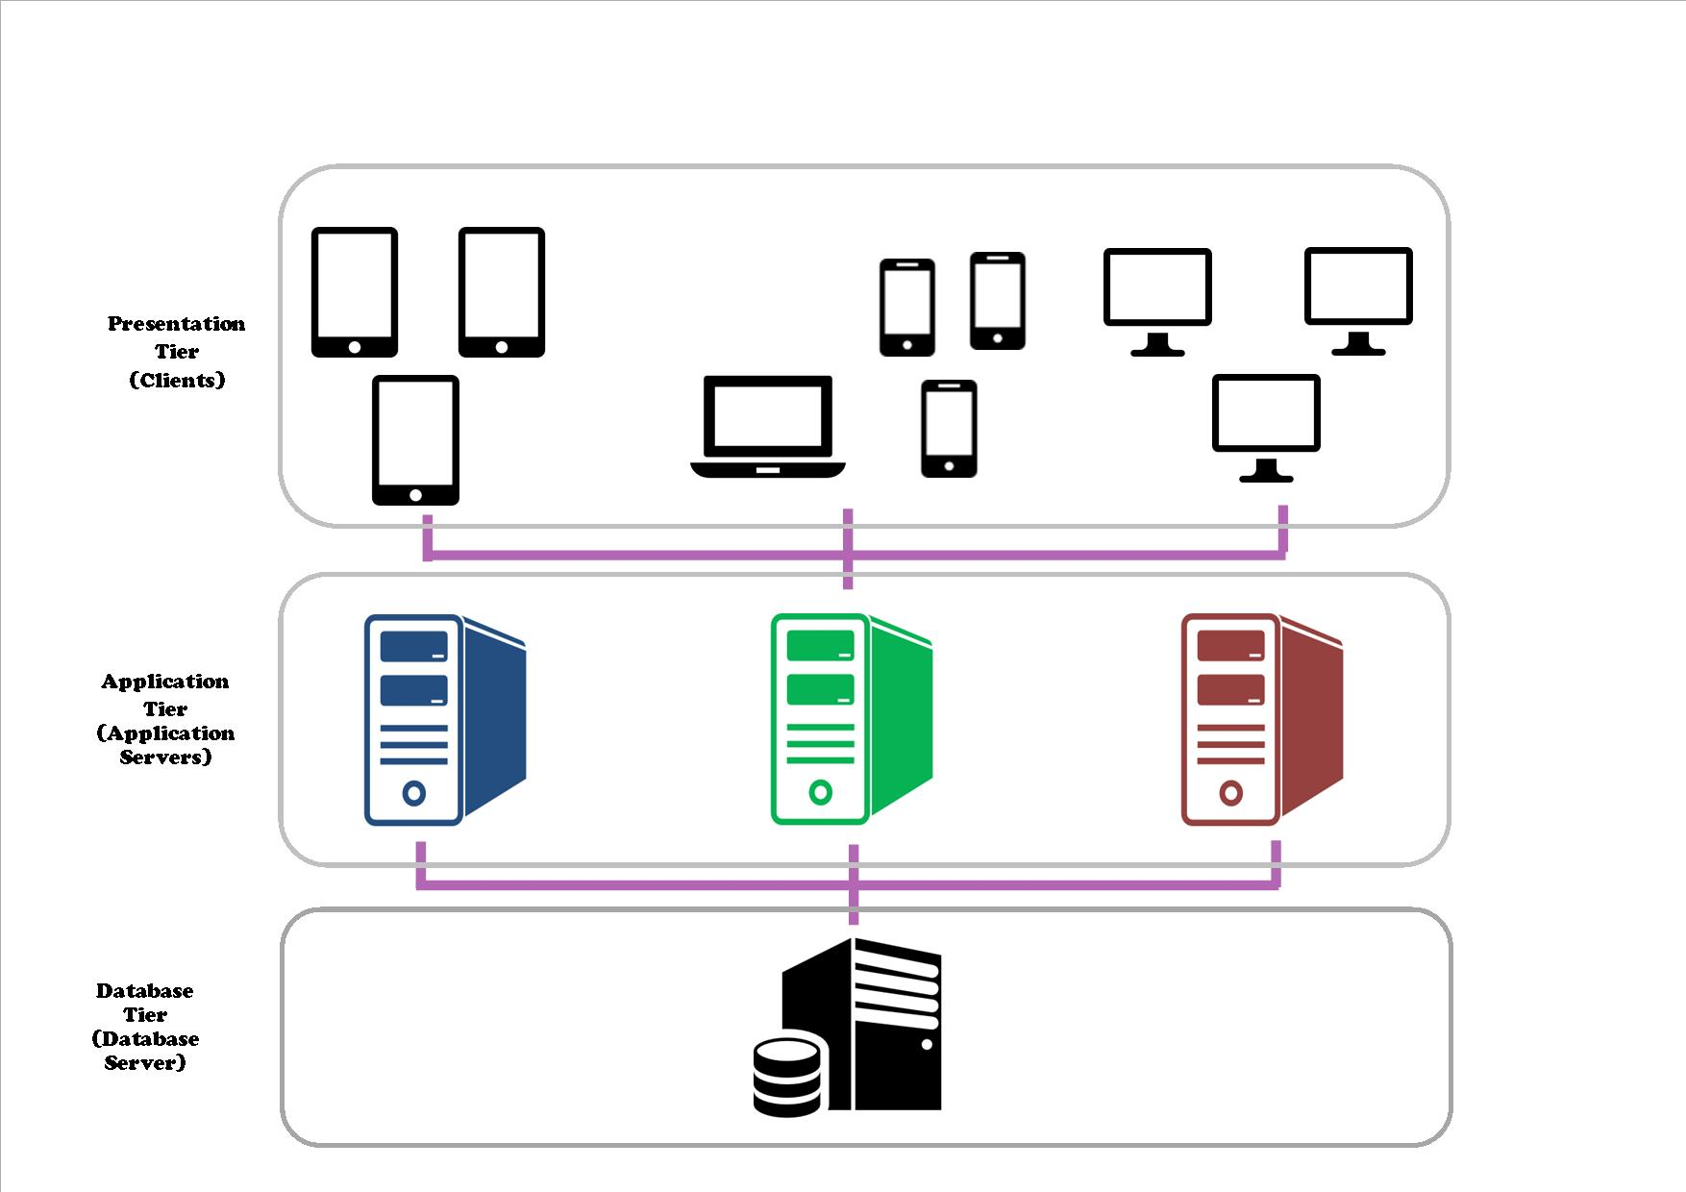

(3-tier Architecture)

The proposed system architecture that we will be using is the 3-tier architecture. The reason for choosing 3-tier architecture due to advantages such as

1. Improve scalability
   1. With the improved scalability 3-tier architecture provides, Mr Wang does not need to worry about the amount of users using the system all at the same time which will not compromise the performance of the system. This is because the application servers has equally distributed deployment, which will lead to a better load balancing of the user’s request to the system. Softwares such as Teleprocessing (TP) monitors are being used to complete the task.
2. Improve data integrity
   1. With Improved Scalability, Mr Wang will not have to worry about wrong information or corrupted data due to the Application Server (middle tier application), validating the data and updating the database with the correct information.
3. Enhance security
   1. With the 3-tier architecture, the client will not be able to communicate directly with the database as it has several layers in the application servers to reduce the risk of unauthorised access to the data. Therefore Mr. Wang will have a more secure system, not having to worry about risks such as unauthorised access.
4. Redundant server ability
   1. Whenever Mr Wang encounters a server failure in his system, with the help of the application server and the database server he will be able to create applications that will be used to recover from these failures.
5. Easy Maintenance
   1. Mr Wang and administrators will have an easier time to manage the system and performing modification on the architecture will be easier as well, not affecting the other modules.

**Reason to choose 3-tier architecture over 2-tier architecture.**

It is true that 2-tier architecture is cheaper to implement and maintain as compared to 3 tier architecture however it has a lot of disadvantages such as performance degrades when there are a lot of users using the system, thus lacking in scalability. If Mr Wang implements the tier 2 architecture and if he requires a new upgrade to improve his system scalability, he would require to recreate his whole system again, with new planning and design which will cost him more cost to do so. Unlike tier 3 architecture it allows to handle more request with better scalability.

Why tier 1 and n-tier architecture is not advisable for Mr Wang’s business.

For tier 1 architecture, it does not provide much security to Mr Wang’s data since the data is being stored on one platform, which could be easily infiltrated by attackers, trying obtain confidential information. Tier 1 architecture requires high maintenance cost. If the system goes down, Mr Wang’s will not be able to have access to the data.

As for n-tier, it will have complex communication due to the number of applications involved in the architecture. With Mr Wang’s current situation, he will also not be able to afford implementing and maintaining the applications.

<https://www.quora.com/What-are-the-advantages-and-disadvantages-of-architecture-1-tier-2-tier-3-tier-and-n-tier>

<http://www.softwaretestingclass.com/what-is-difference-between-two-tier-and-three-tier-architecture/>

<https://www.google.com.sg/url?sa=i&rct=j&q=&esrc=s&source=images&cd=&cad=rja&uact=8&ved=0ahUKEwjp5Y2s2IbUAhVLro8KHaiACjAQjRwIBw&url=https%3A%2F%2Fthesapadventure.wordpress.com%2F2015%2F03%2F23%2Fbasics-blast-systems-architecture%2F&psig=AFQjCNF4toHx6q4A0_zGVWRbKM01Qx_V1Q&ust=1495652073956191>

# **3.** **USER INTERFACE (UI) DESIGN**

*[Document the user interface design decisions and considerations. This should not be a mere capture of all UI forms but a reflection of UI design considerations. Is web or windows or other forms of UI used? Why did you choose that particular UI? How does the UI design impact usability and why adopt certain UI controls than others?]*

# 

# 

# 

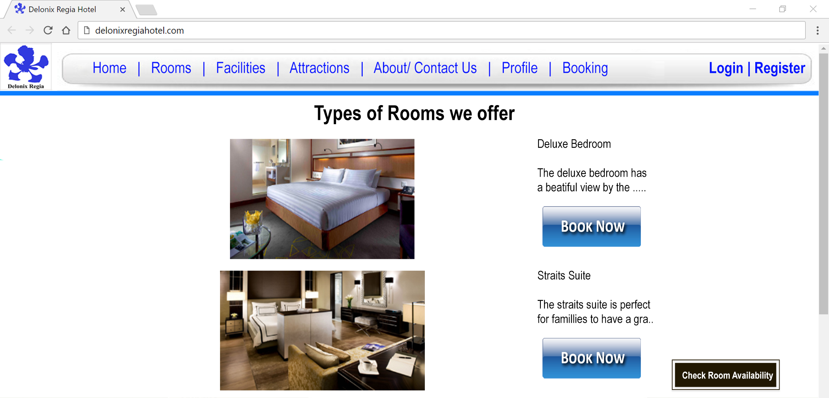

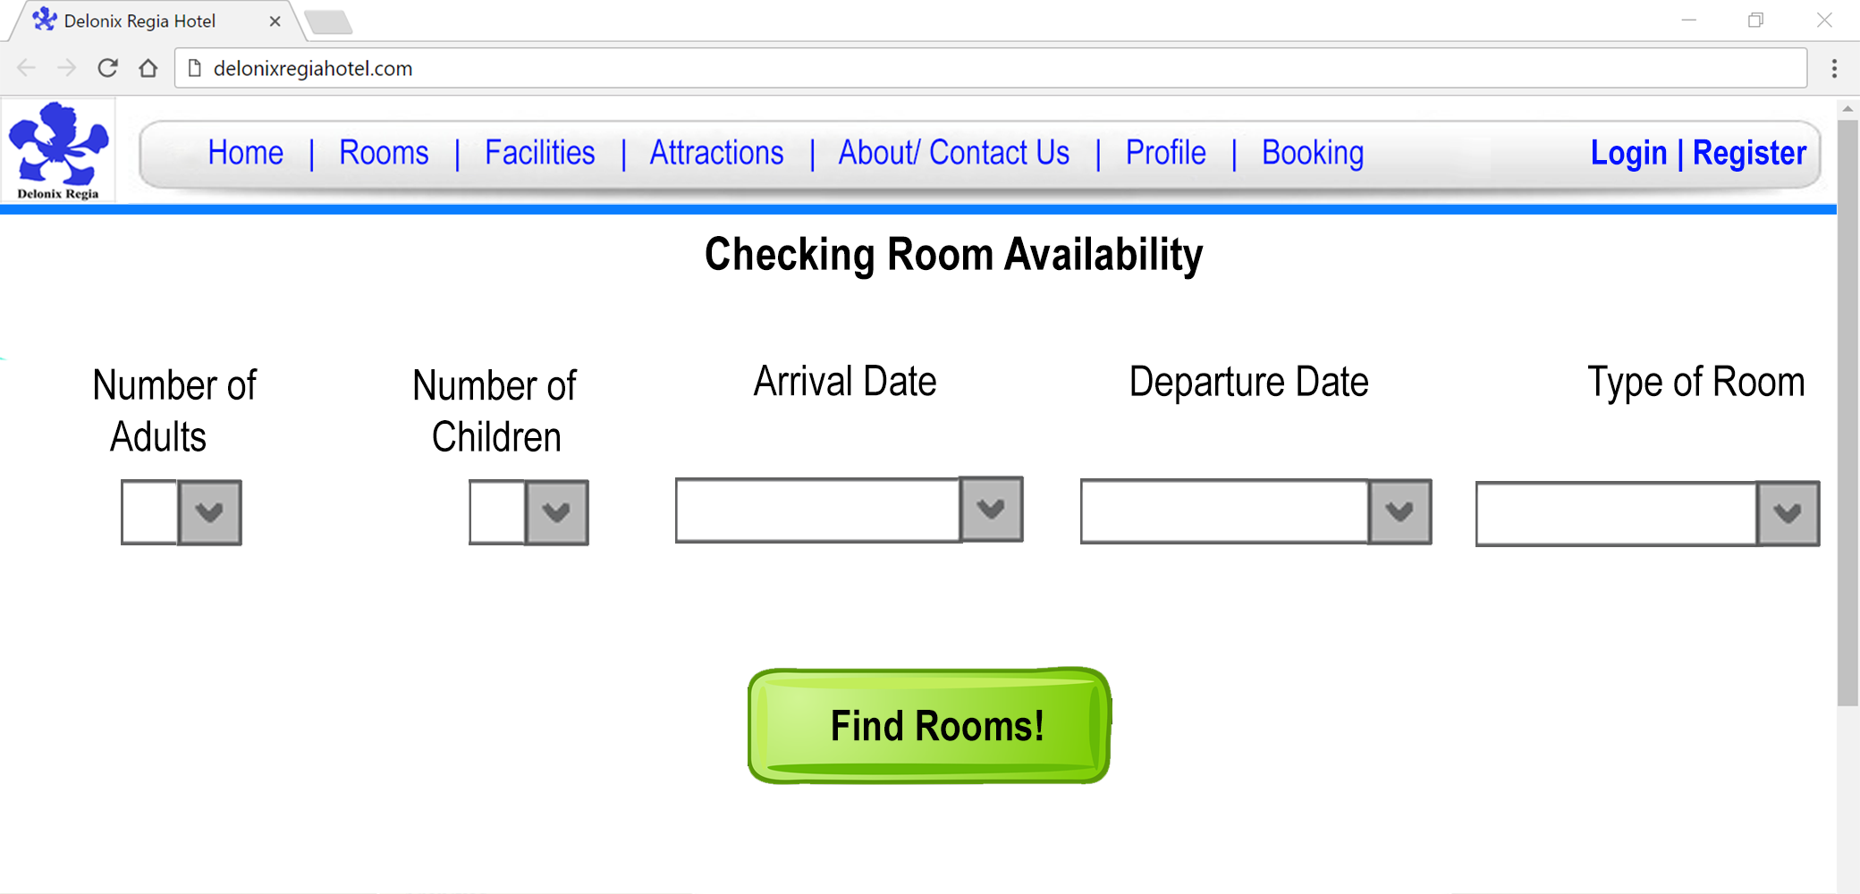

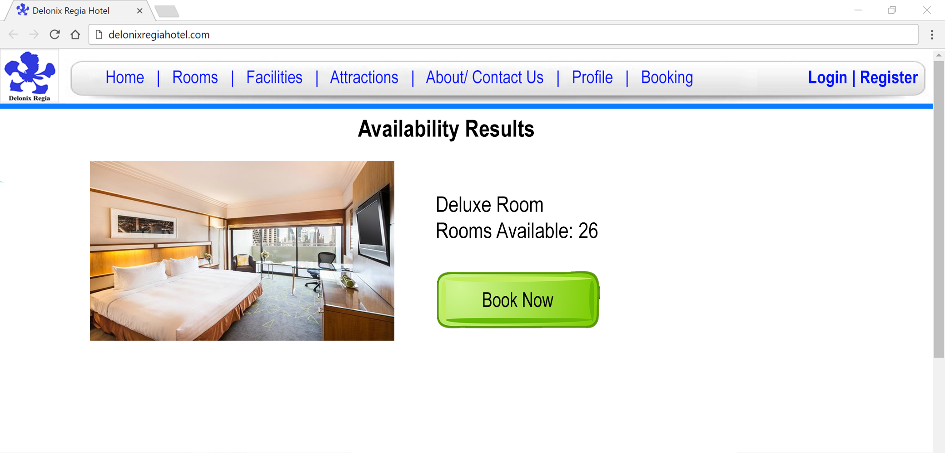

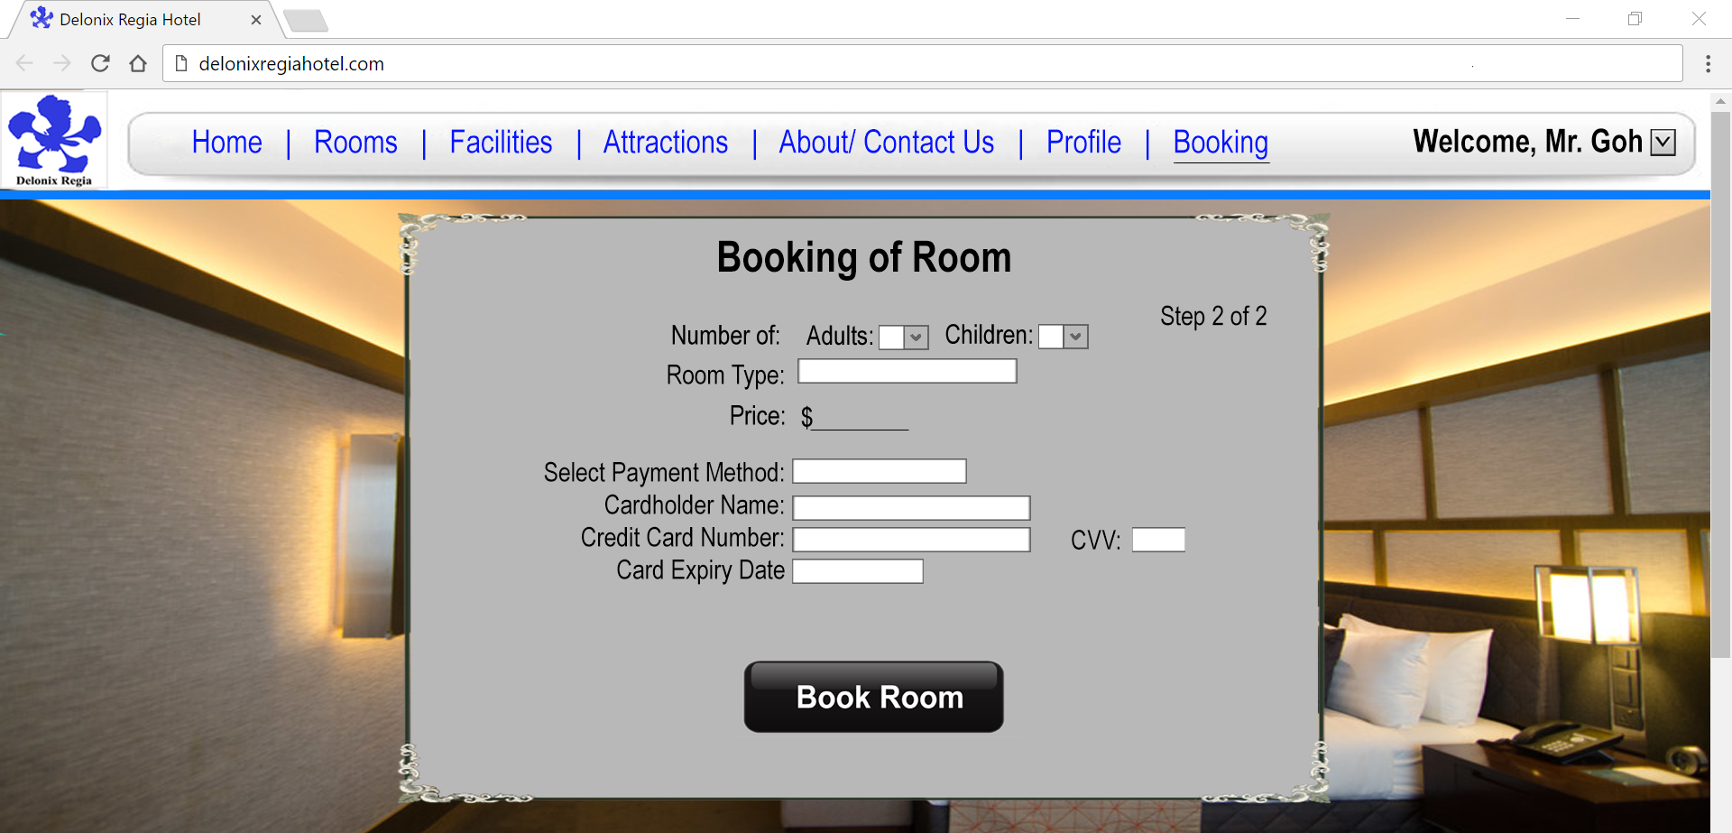

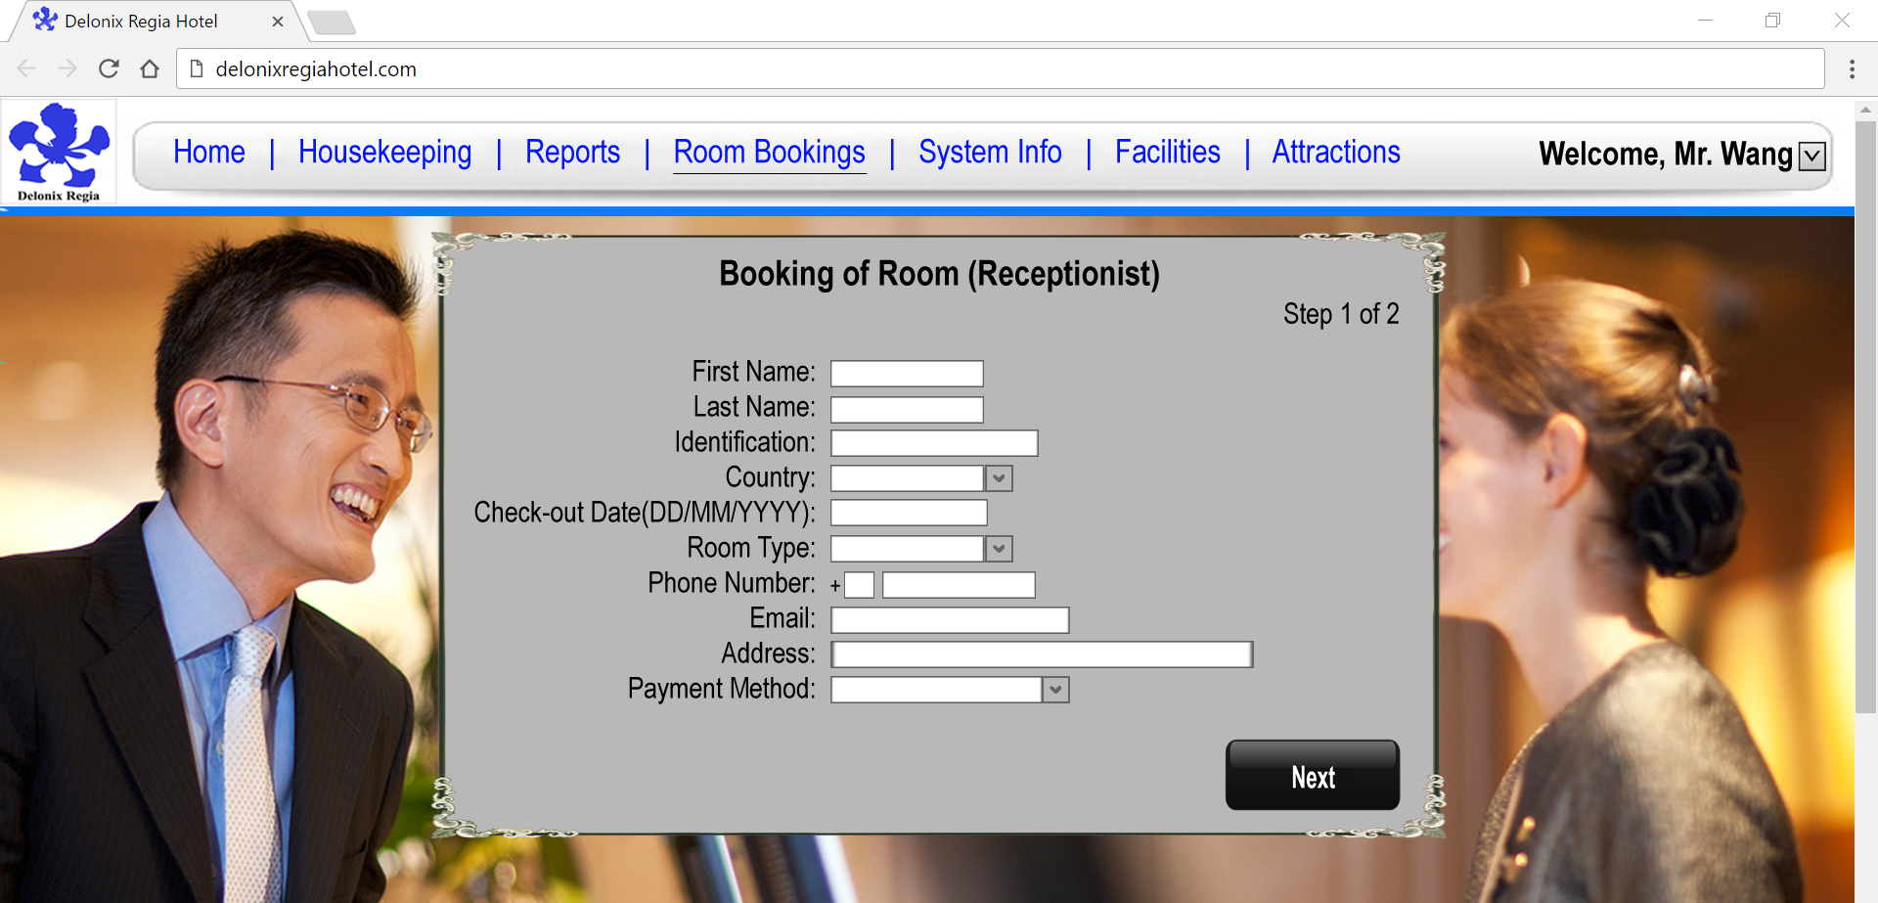

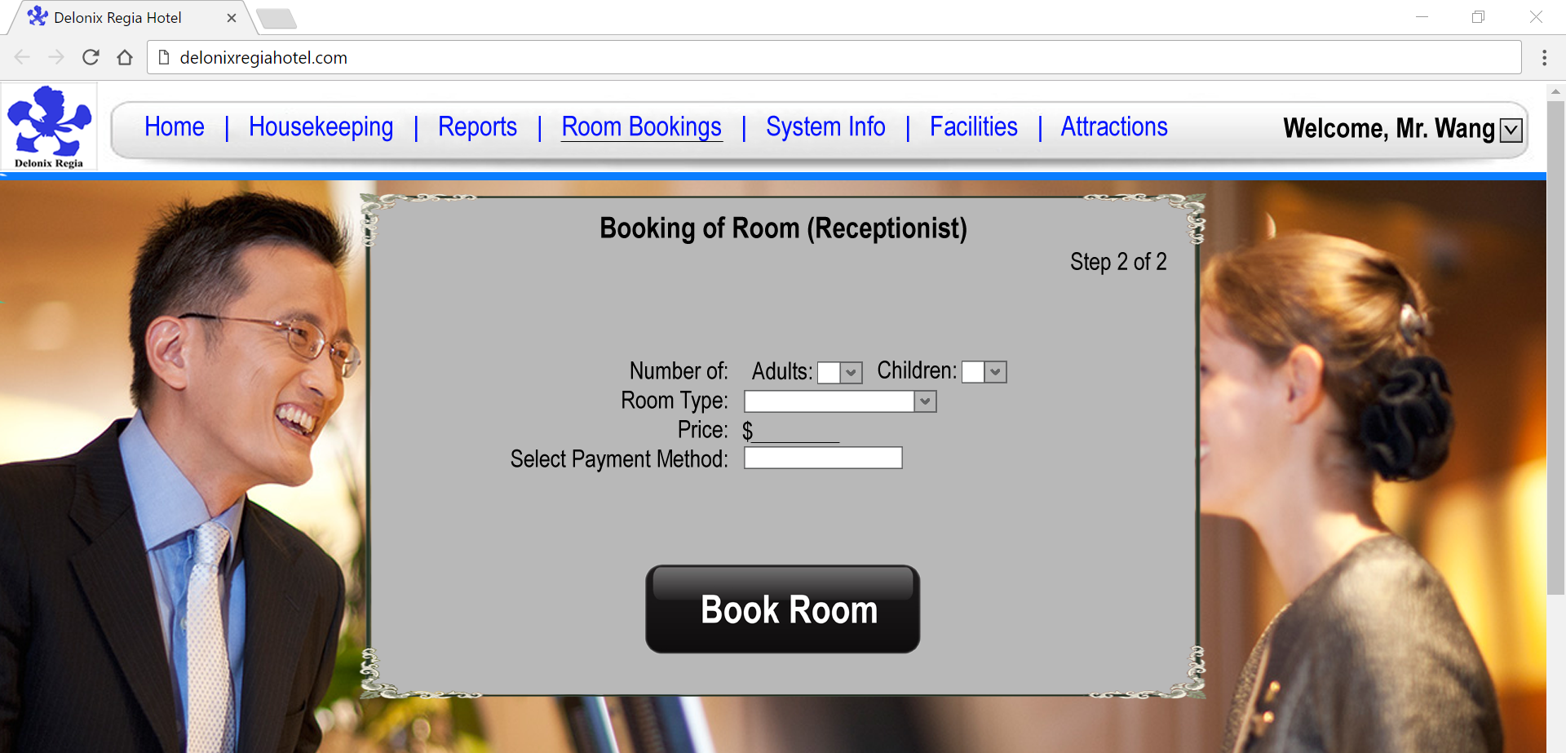

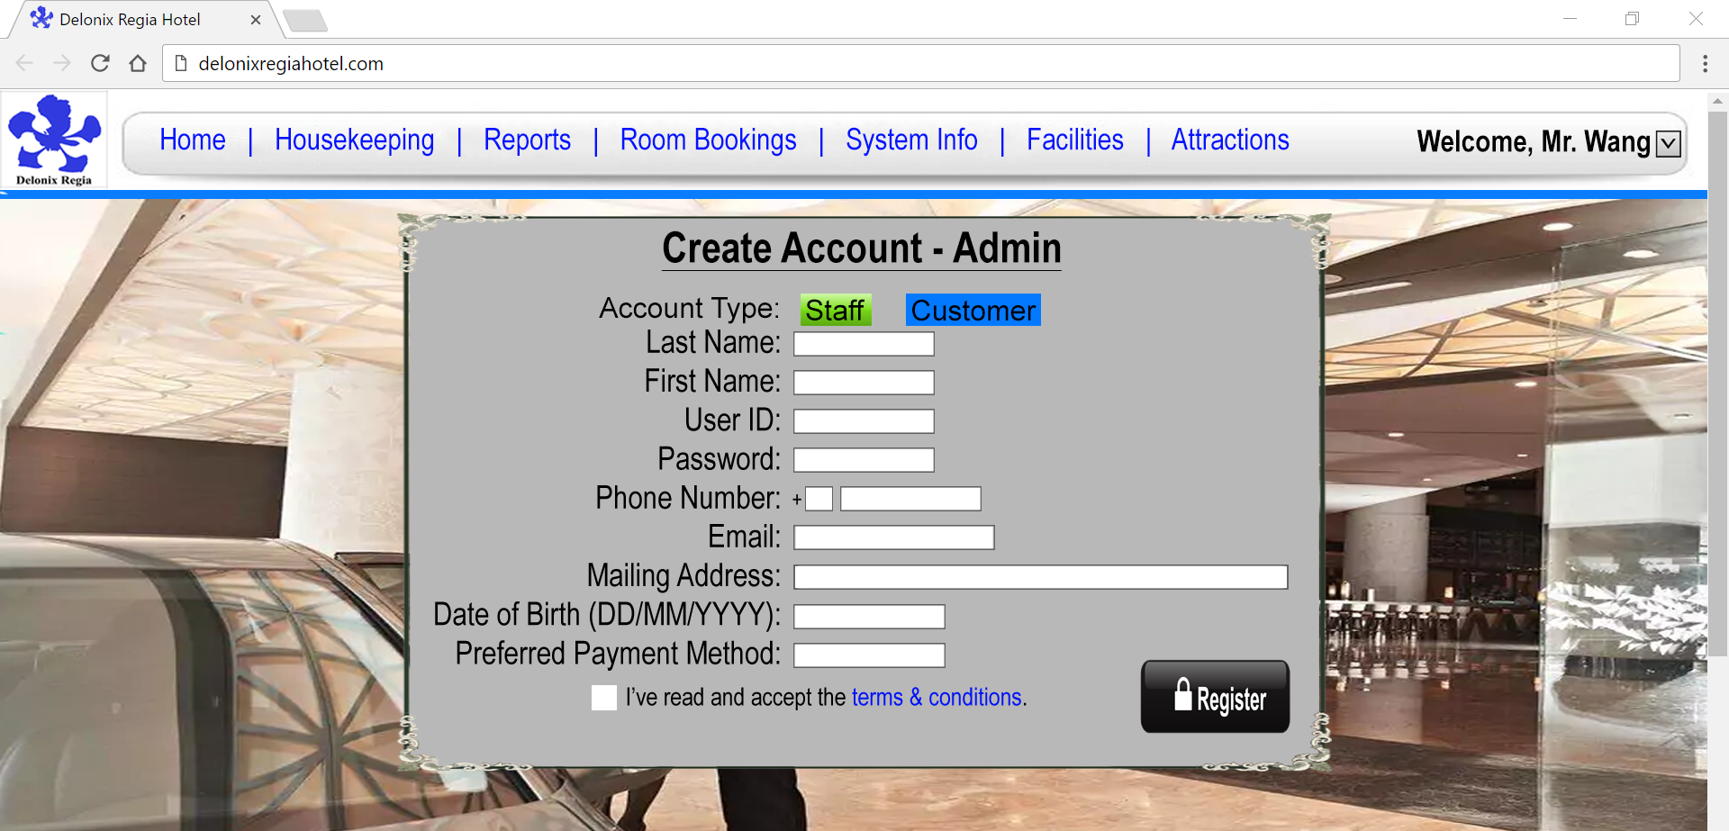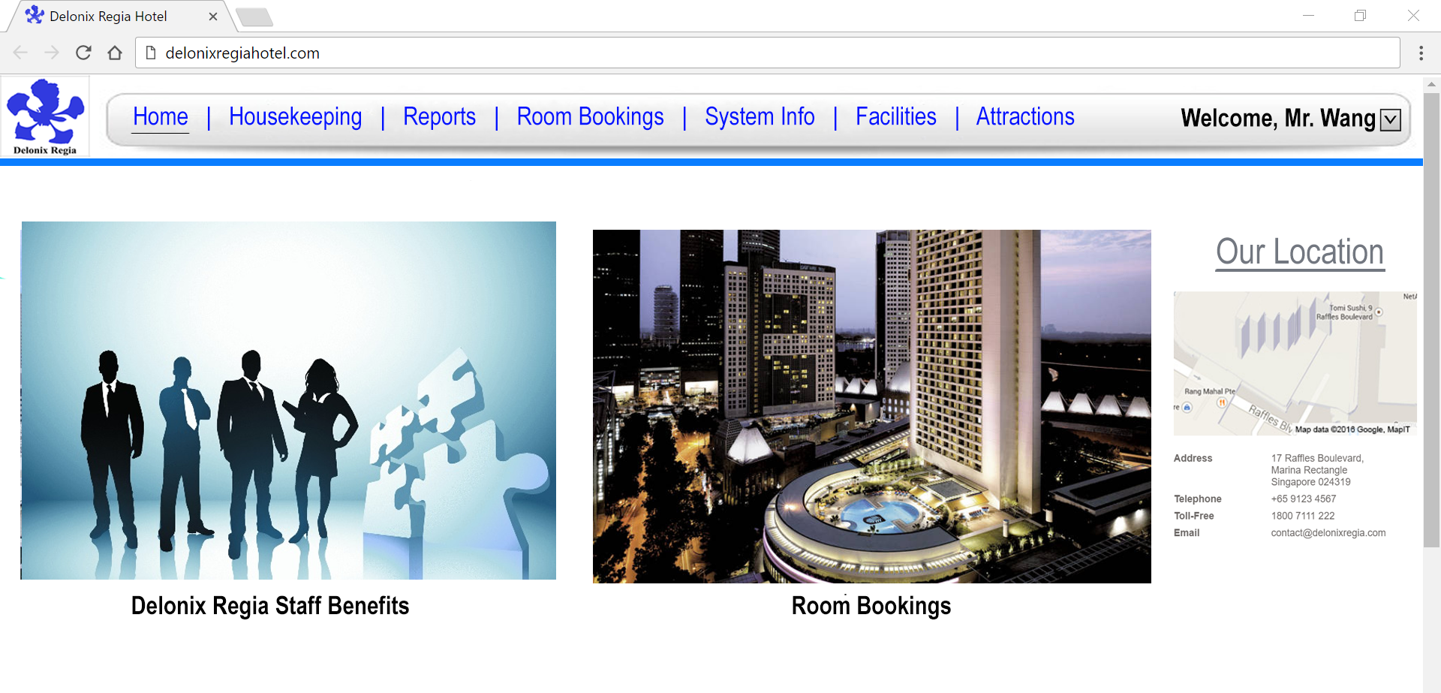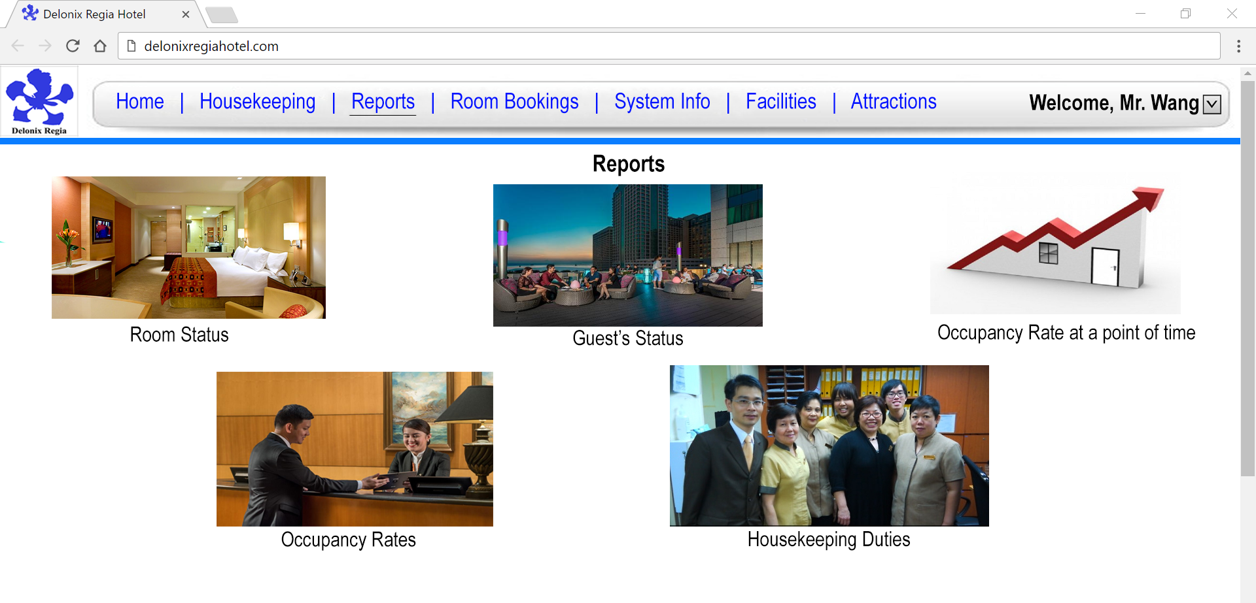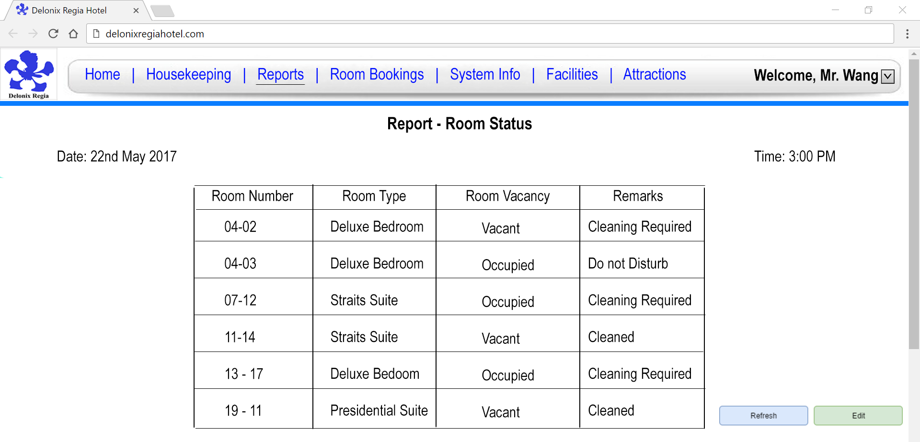

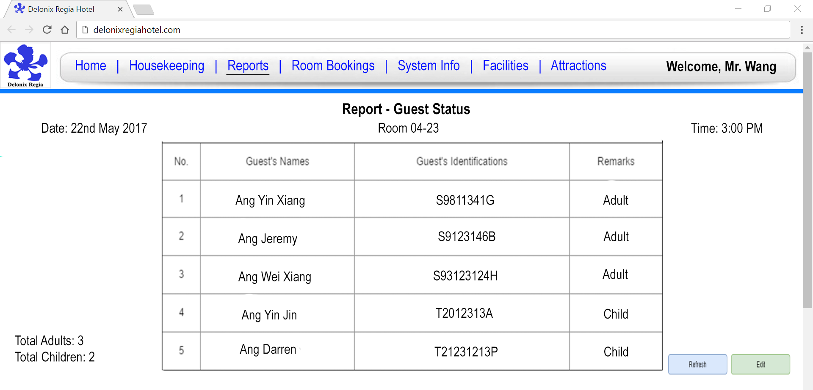

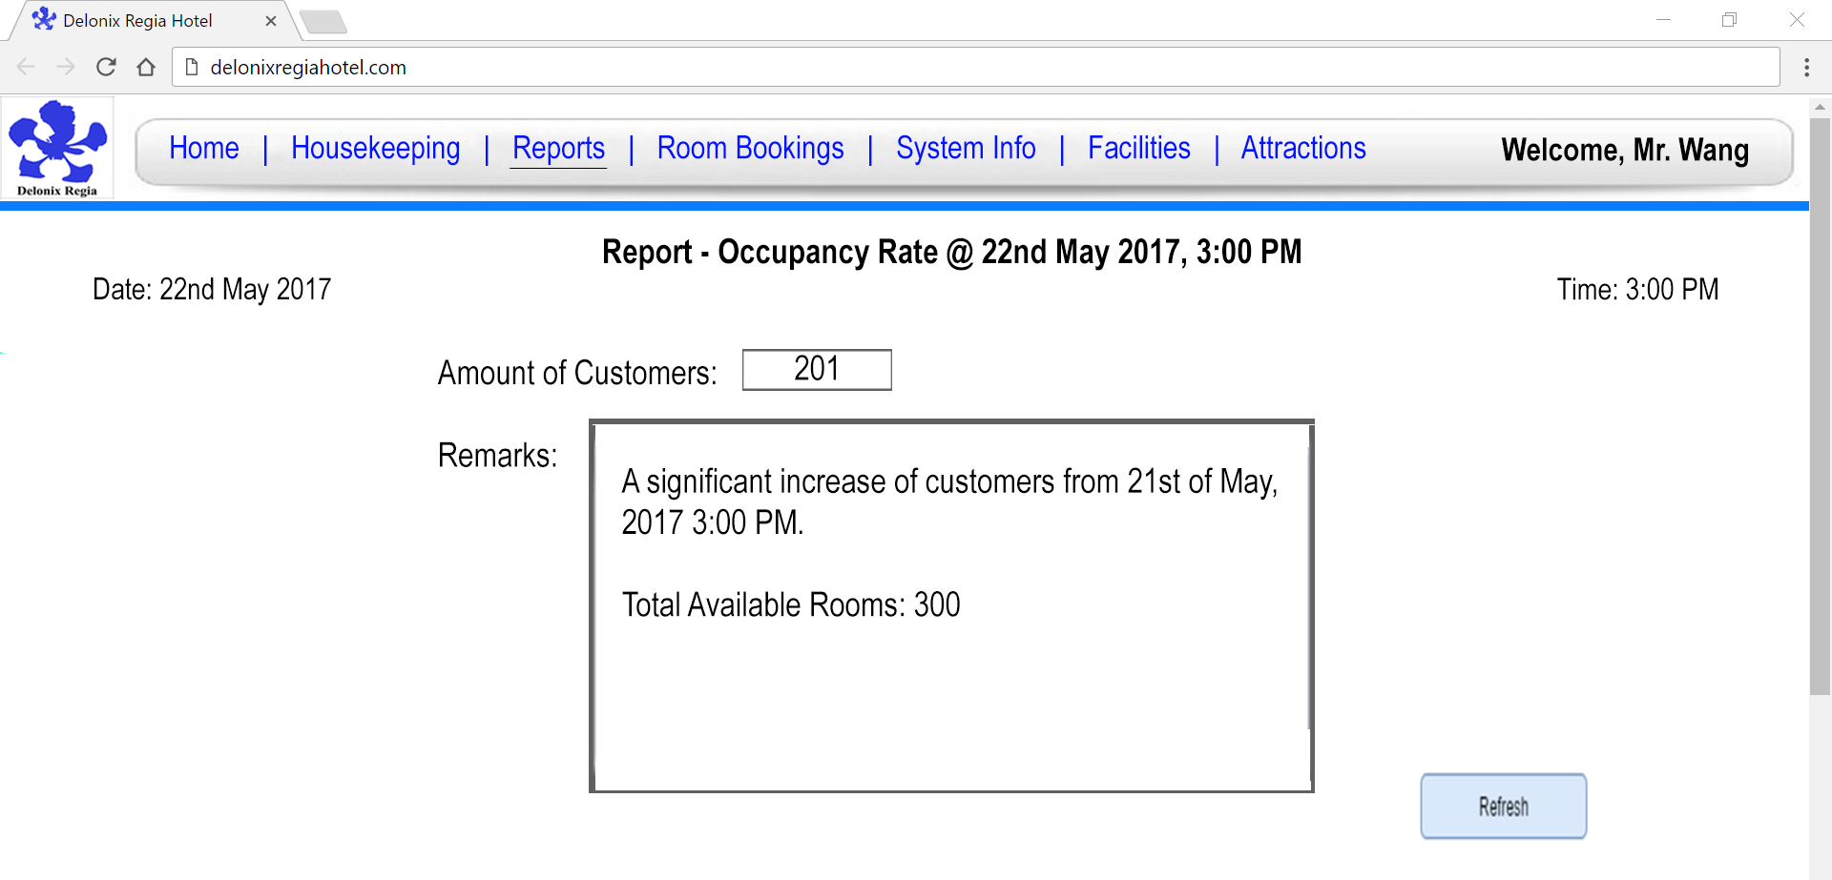

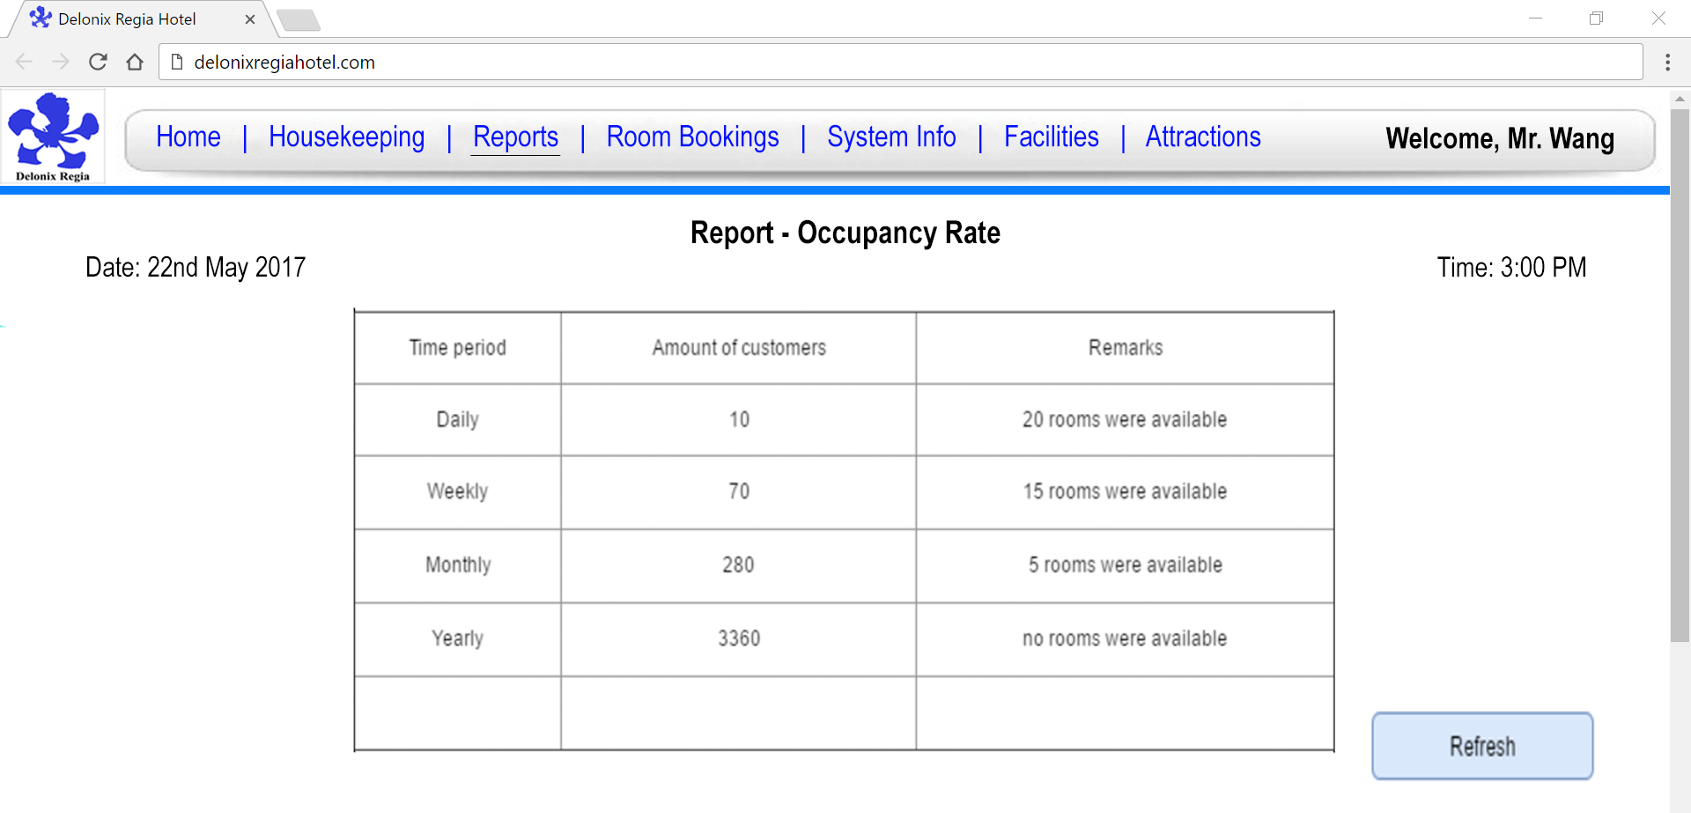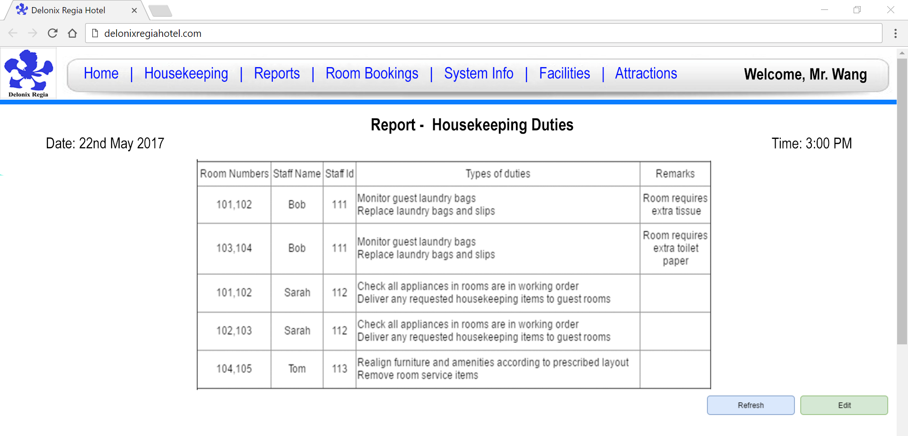

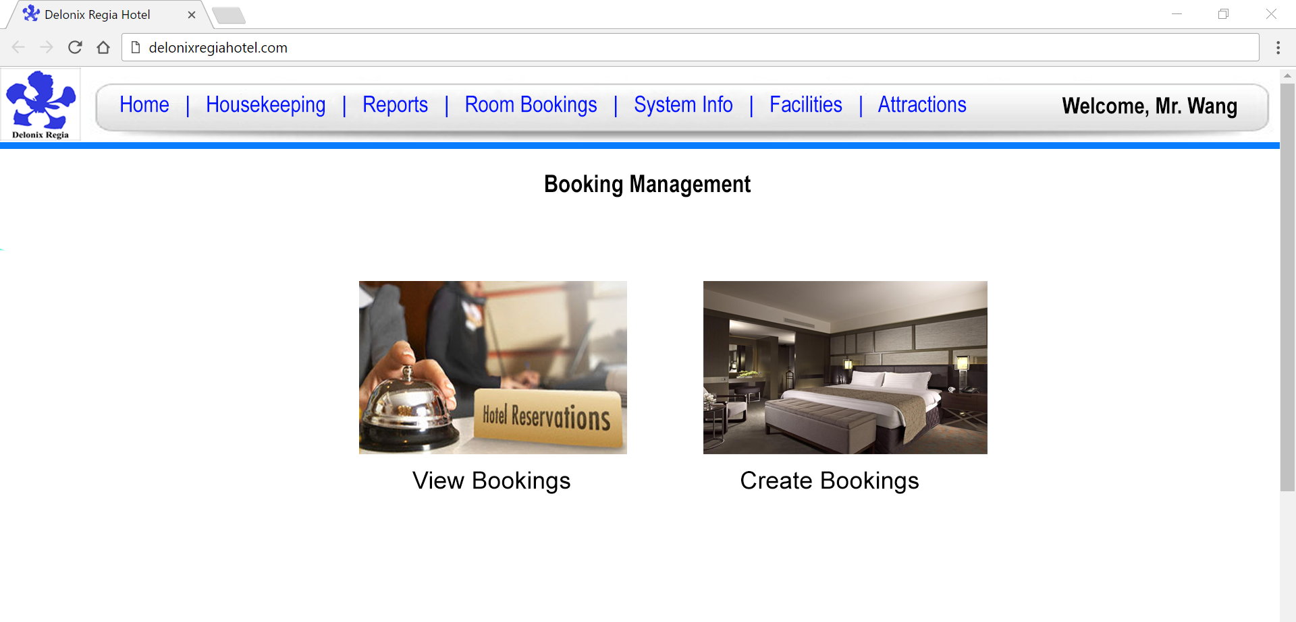

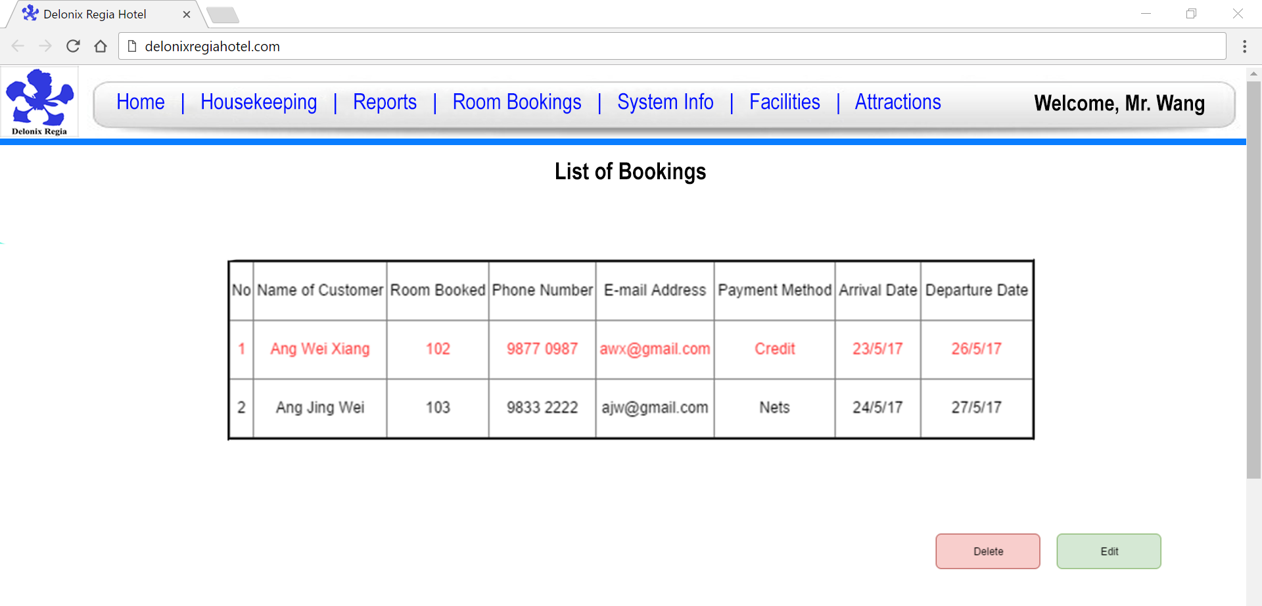

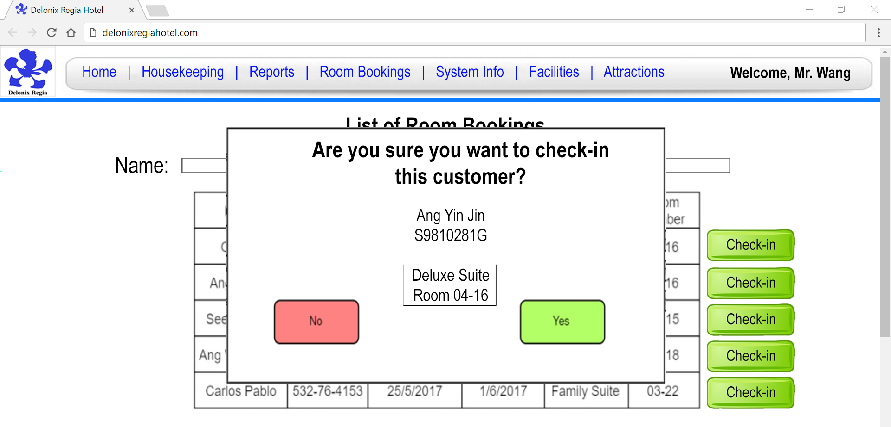

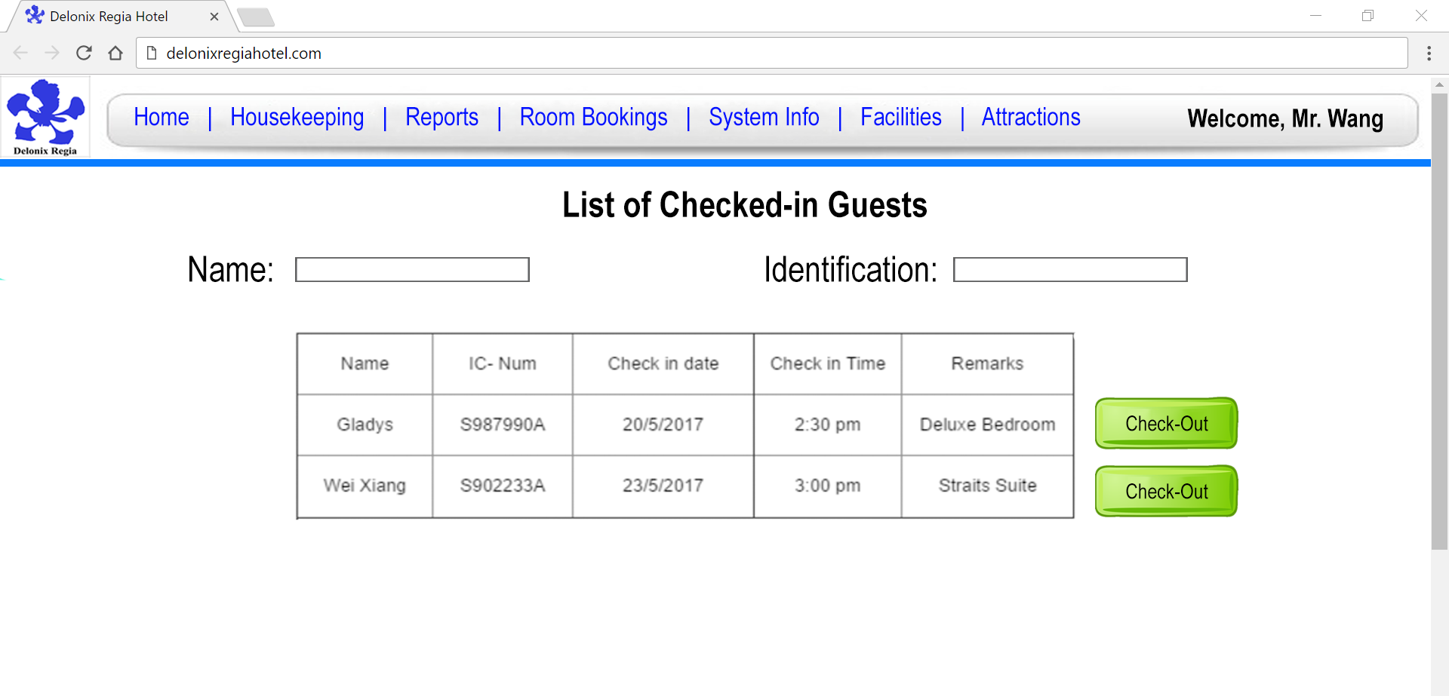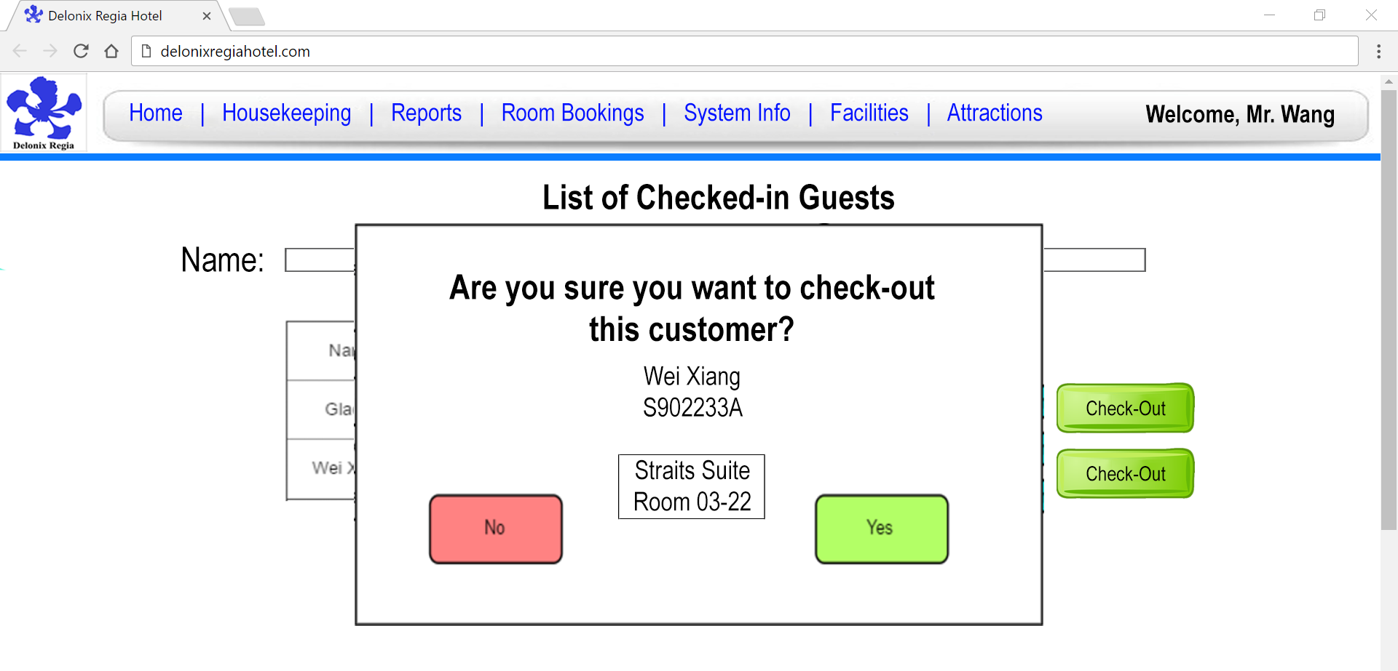

**HomePage**

1Book in page

2Check Available Rooms page

3About Us/Contact Us Page

4Availability of room

Checking in Page

Checking out Page

Booking Hotel Facilities

Checkout/Payment Page

Attractions page

Login Page

User profile

Check housekeeping schedule

Create account (admin)

Forget Password

Live Chat (implemented in phase 2)

# 

# **4.** **PROGRAM DESIGN**

*[Describe how program design is done. What are the programs making up each system/software module?]*

*VOPC, Sequence Diagram, Use Case Diagram*

**Use Case Diagram**

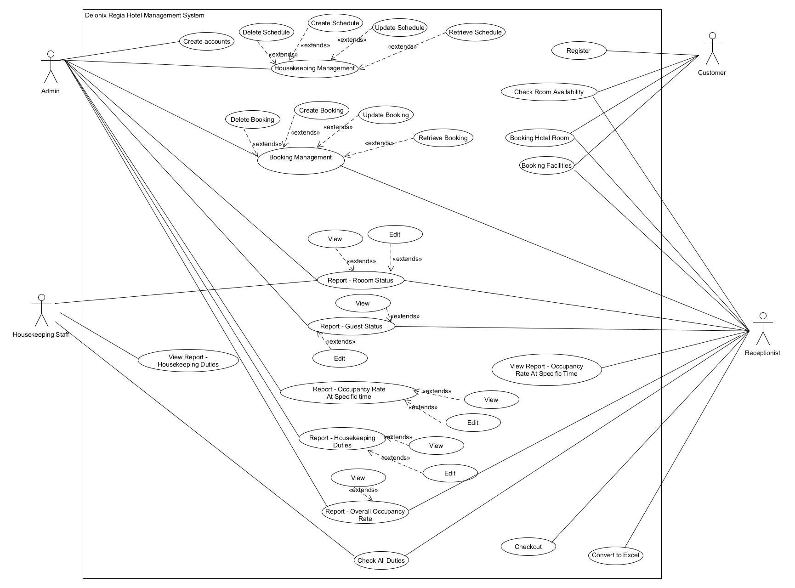

**Basic Flows and Alternative Flows**

**Use Case:** Register

**Brief Description:** Customer can create an account to use our system to book the hotel rooms. Upon creation user will have more access to the functions in the system

**Actors:** Customer

**Flow of Events:**

**Main Flow:**

1. Use case start when customer select on the register option.
2. The system display the register form.
3. Customer proceed to fill up the form.
4. Customer checks UserID availability.
5. Customer accepts terms and condition
6. System verify the details.
7. System prompt confirmation with the customer.
8. Customer confirm the form.
9. System store the details and the use case end.

**Alternative Flow of Events:**

**Invalid user name**

- If customer enter invalid user name, system will display an error message on the invalid field.

- Customer will need to re-enter the form in step (3).

**Email used**

- If customer enter used email, system will display an error message on the invalid field.

- Customer will need to re-enter the form in step (3).

**UserID used**

- If customer enter used userID, system will display an error message on the invalid field.

- Customer will need to re-enter the form in step (3).

- Customer will need to re-confirm UserID in step (4)

**Basic Flows and Alternative Flows**

**Use Case:** Create Accounts

**Brief Description:** Admin can perform creation of account for both staff and customers. Upon creating the account, will grant access to functions in the system depending on the user.

**Actors:** Admin

**Flow of Events:**

**Main Flow:**

1. Use case start when admin select on the register option.
2. The system display the register form.
3. Admin proceed to fill up the form.
4. Admin checks UserID availability.
5. Admin accepts terms and condition
6. System verify the details.
7. System prompt confirmation with the customer.
8. Admin confirm the form.
9. System store the details and the use case end.

**Alternative Flow of Events:**

**Invalid user name**

- If Admin enter invalid user name, system will display an error message on the invalid field.

- Admin will need to re-enter the form in step (3).

**Email used**

- If customer enter used email, system will display an error message on the invalid field.

- Admin will need to re-enter the form in step (3).

**UserID used**

- If customer enter used userID, system will display an error message on the invalid field.

- Admin will need to re-enter the form in step (3).

- Admin will need to re-confirm UserID in step (4)

**Basic Flows and Alternative Flows**

**Use Case:** Housekeeping management

**Brief Description:** Admin can add, delete and edit the schedule.

**Actors:** Admin

**Flow of Events:**

**Main Flow:**

1. The use case start when the user selects the manage housekeeping option.
2. System will display a list of schedule
3. Admin select an option.
4. If user select add schedule option, go to Add schedule.
5. If user select update schedule option, go to Update schedule.
6. If user select delete schedule option, go to Delete schedule.

**Alternative Flow of Events:**

**Add schedule**

1. System display a form for admin to fill in the details.
2. The system verifies the new schedule and add into the system.
3. The use case end when the system displays a message notifying the admin that the new schedule had been added.

**Update schedule**

1. Admin select an schedule and choose the edit option.
2. System display a form with the current schedule filled in the field.
3. Admin then edit the changes that are needed and select save options
4. System verify the schedule and save the changes.
5. The use case end when the system displays a message notifying the admin that the details had changed successfully.

**Delete schedule**

1. Admin select an schedule and choose the delete option.
2. The system will prompt the user for confirmation to delete schedule.
3. Admin confirm with the system.
4. The system removes the schedule.
5. The use case end when the system displays a message notifying the user that the schedule had been successfully deleted.

**Basic Flows and Alternative Flows**

**Use Case:** Booking management

**Brief Description:** Admin and receptionist can add, delete and edit the booking.

**Actors:** Receptionist and admins

**Flow of Events:**

**Main Flow:**

1. The use case start when the user selects the manage booking option.
2. System will display options for the user to choose
3. The user select an option.
4. If user select add booking option, go to Create booking.
5. If user select view booking option, go to View booking

**Alternative Flow of Events:**

**Add booking**

1. System will redirect the user to the booking page and the use case end.

**View booking**

1. If the user select the update booking option, go to Update booking.
2. If the user select the delete booking option, go to Delete booking.
3. The system display a list of booked in and the use case end.

**Update booking**

1. User select the field they want to update and change the information and select save.
2. The system verify the details and save the changes and the use case end.

**Delete booking**

1. User select a booking that they want to delete and click on the delete option.
2. The system prompt for confirmation about the delete.
3. The user confirm the delete.
4. The system remove the booking and the use case end.

**Basic Flows and Alternative Flows**

**Use Case:** Check duties

**Brief Description:** The check duties function allows the receptionist and housekeeping staff to check their work schedule.

**Actors:** Housekeeping staff and receptionist

**Flow of Events:**

**Main Flow:**

1. Use case start when user select on the view schedule option.
2. The system display a table filled with data that contains their schedule and the use case end.

**Basic Flows and Alternative Flows**

**Use Case:** Booking of Rooms

**Brief Description:** Customers and Receptionist are able to perform booking of rooms

**Actors:** Customer & Receptionist

**Flow of Events:**

**Main Flow:**

1. Use case start when the user selects booking from the homepage.
2. The system displays the booking form.
3. The users proceeds to fill in the form.
4. The system verifies the data
5. The system prompts for confirmation.
6. The user confirms the booking form
7. The use case ends when the system displays a success page.

**Alternative Flow of Events:**

**Invalid Payment Details (Customers)**

* If the credit card details that is being entered is in the booking form is invalid
* There will be an error message telling the customer that invalid payment data has been entered. Or unknown credit card details.
* Customer is required to re-enter the missing information in the forms in step (3)

**Basic Flows and Alternative Flows**

**Use Case:** Check availability of rooms

**Brief Description:** This function allows the receptionist and customer to check whether there is available hotel rooms based on a particular date and arrival time.

**Actors:** Customer and receptionist

**Flow of Events:**

**Main Flow:**

1. The use case start when the user select the check availability option
2. The system prompt the user for the required information
3. The user enter the information and select the check option
4. The system will display a list of available rooms and the use case end.

**Alternative Flow of Events:**

**No rooms available**

- If there is no room available the system will display a message telling the user that there is no room available on that particular day and arrival time.

- The system then redirect the user back to step (2).

**Basic Flows and Alternative Flows**

**Use Case:** Check availability of rooms

**Brief Description:** This function allows the receptionist and customer to check whether there is available hotel rooms based on a particular date and arrival time.

**Actors:** Customer and receptionist

**Flow of Events:**

**Main Flow:**

1. The use case start when the user select the check availability option
2. The system prompt the user for the required information
3. The user enter the information and select the check option
4. The system will display a list of available rooms and the use case end.

**Alternative Flow of Events:**

**No rooms available**

- If there is no room available the system will display a message telling the user that there is no room available on that particular day and arrival time.

- The system then redirect the user back to step (2).

**Basic Flows and Alternative Flows**

**Use Case:** Checking out hotels rooms

**Brief Description:** This function allows the receptionist to help customer to check out of their room.

**Actors:** Receptionist

**Flow of Events:**

**Main Flow:**

1. The use case start when the user select the list of checked in customer.
2. The system display a list of checked in customer.
3. The user search for the name or identification number of the customer.
4. The system display the checked in details based on the name.
5. The user select the check out button for the customer.
6. The system prompt for confirmation.
7. User confirm and the use case end.

**Alternative Flow of Events:**

**No search results found**

- If there is no search results found then the system will display a message telling the user that there is no search result found.

- The system then redirect the user back to step (2).

**Basic Flows and Alternative Flows**

**Use Case:** Report - Room Status

**Brief Description:** This function helps to display the room status in the hotel

**Actors:** Admin, Housekeeping and Receptionist

**Flow of Events:**

**Main Flow:**

1. The use case start when the user hovers over their userID/name and selects the Report
2. The system display a list of reports
3. The user selects the Room Status Report
4. The user selects the date and time.
5. The use case ends when the system displays the list of Rooms with their Status

**Alternative Flow of Events:**

**Update the Room Status:**

1. The user selects Edit Option.
2. The system displays the list of Room Status, with enabled edit functions
3. The User makes changes to the list.
4. The user selects the save option.
5. The system displays confirmation message.
6. The user selects the save option.
7. The use case ends when the system display the updated list of rooms.

**Basic Flows and Alternative Flows**

**Use Case:** Displays Report - Room Status

**Brief Description:** This function helps to display the room status in the hotel

**Actors:** Admin, Housekeeping and Receptionist

**Flow of Events:**

**Main Flow:**

1. The use case start when the user hovers over their userID/name and selects the Report
2. The system display a list of reports
3. The user selects the Room Status Report
4. The user selects the date and time.
5. The use case ends when the system displays the list of Rooms with their Status

**Alternative Flow of Events:**

**Update the Room Status:**

1. The user selects Edit Option.
2. The system displays the list of Room Status, with enabled edit functions
3. The User makes changes to the list.
4. The user selects the save option.
5. The system displays confirmation message.
6. The user selects the save option.
7. The use case ends when the system display the updated list of rooms.

**Basic Flows and Alternative Flows**

**Use Case:** Displays Report - Guest Status

**Brief Description:** This function helps to display the guest status of a particular room in the hotel

**Actors:** Admin and Receptionist

**Flow of Events:**

**Main Flow:**

1. The use case start when the user hovers over their userID/name and selects the Report
2. The system display a list of reports
3. The user selects the Guest Status Report
4. The user selects the date, time and room number.
5. The use case ends when the system displays the list of Guests with their status

**Alternative Flow of Events:**

**Update the Room Status:**

* 1. The user selects Edit Option.
  2. The system displays the list of Guests Status, with enabled edit functions
  3. The User makes changes to the list.
  4. The user selects the save option.
  5. The system displays confirmation message.
  6. The user selects the save option.
  7. The use case ends when the system display the updated list of guests.

**Basic Flows and Alternative Flows**

**Use Case:** Displays Report - Occupancy Rate at point of time

**Brief Description:** This function helps to display the report of Occupancy Rate at the selected point of time.

**Actors:** Admin and Receptionist

**Flow of Events:**

**Main Flow:**

1. The use case start when the user hovers over their userID/name and selects the Report
2. The system display a list of reports
3. The user selects the Occupancy Rate at Point of Time Report
4. The user selects the date and time
5. The use case ends when the system displays the amount of customers and the remarks.

**Alternative Flow of Events:**

**Update the Room Status (Admin):**

1. The user selects Edit Option.
2. The system displays the amount of customers and remarks, with enabled edit functions
3. The User makes changes to the information.
4. The user selects the save option.
5. The system displays confirmation message.
6. The user selects the save option.
7. The use case ends when the system display the updated occupancy rate at the point of time information.

**Basic Flows and Alternative Flows**

**Use Case:** Displays Report - Occupancy Rate

**Brief Description:** This function helps to display the report of Occupancy Rate.

**Actors:** Admin and Receptionist

**Flow of Events:**

**Main Flow:**

1. The use case start when the user hovers over their userID/name and selects the Report
2. The system display a list of reports
3. The user selects the Occupancy Rate
4. The user selects the date and time
5. The use case ends when the system displays the list of occupancy rates.

**Basic Flows and Alternative Flows**

**Use Case:** Displays Report - Housekeeping Duties

**Brief Description:** This function helps to display the report of the Housekeeping Duties.

**Actors:** Admin and Housekeeping staff

**Flow of Events:**

**Main Flow:**

1. The use case start when the user hovers over their userID/name and selects the Report
2. The system display a list of reports
3. The user selects the Housekeeping Duties Report
4. The user selects the date and time
5. The use case ends when the system list of housekeeping duties.

**Alternative Flow of Events:**

**Update the Room Status (Admin):**

1. The admin selects Edit Option.
2. The system displays the list of housekeeping duties, with enabled edit functions
3. The admin makes changes to the information.
4. The admin selects the save option.
5. The system displays confirmation message.
6. The admin selects the save option.
7. The use case ends when the system display the updated list of housekeeping duties information.

**Basic Flows and Alternative Flows**

**Use Case:** Update profile

**Brief Description:** This function allows the customer to update their own profile

**Actors:** Customer, Housekeeping staff, admin, receptionist

**Flow of Events:**

**Main Flow:**

1. The use case start when the user select view profile option
2. The system display their profile information
3. The user select the update button
4. The system display a form with the current information filled in the field.
5. The user change the information of what they want and select update.
6. The system verify the information.
7. The system direct the user back to the view profile page and the use case end.

**Alternative Flow of Events:**

**Invalid information**

- If the user entered invalid information into the system it will show an error message and the update won’t be successful.

- The system direct the user back to step (4).

**Basic Flows and Alternative Flows**

**Use Case:** Booking of facilities

**Brief Description:** Customers and Receptionist are able to perform booking of facilities

**Actors:** Customer & Receptionist

**Flow of Events:**

**Main Flow:**

1. Use case start when the user selects facilities from the homepage.
2. The system displays list of available facilities.
3. The users proceeds to fill in the form.
4. The system verifies the data
5. The system prompts for confirmation.
6. The user confirms the booking form
7. The use case ends when the system displays a success page.

**Alternative Flow of Events:**

**Invalid Information**

* If the information are invalid the system will display an error message and redirect the user back to step (3)

**Sequence Diagram**

Figure 1: Register

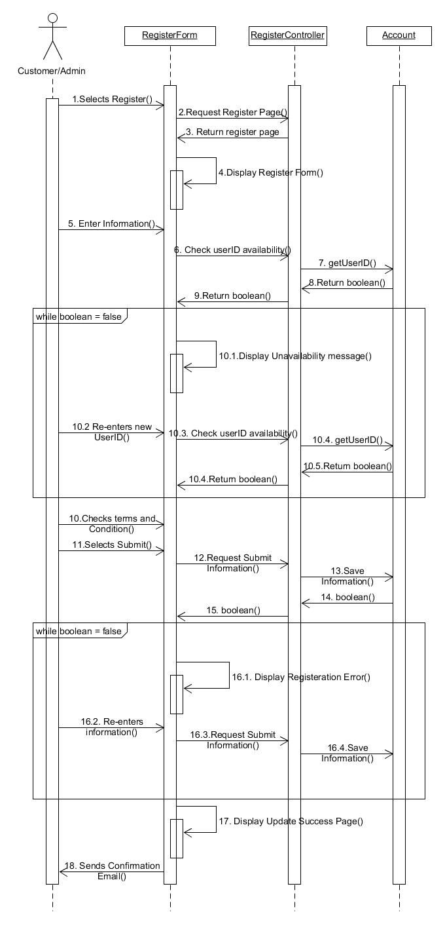

Figure 2: View/Update Profile

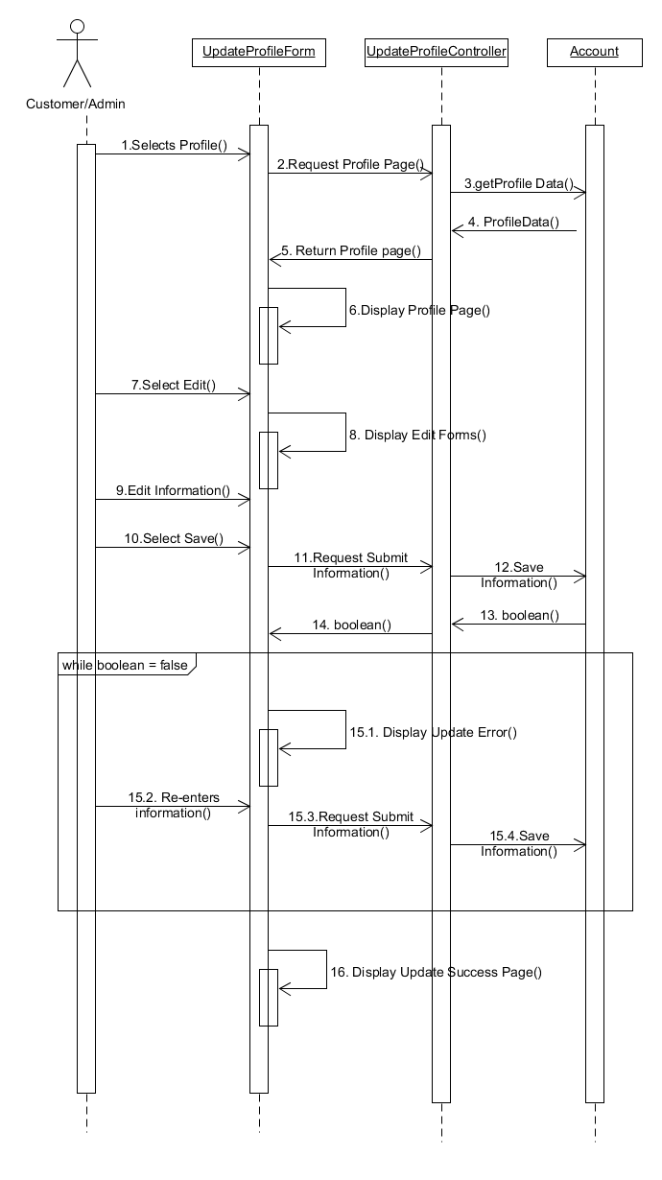

Figure 3: Checking Room Availability

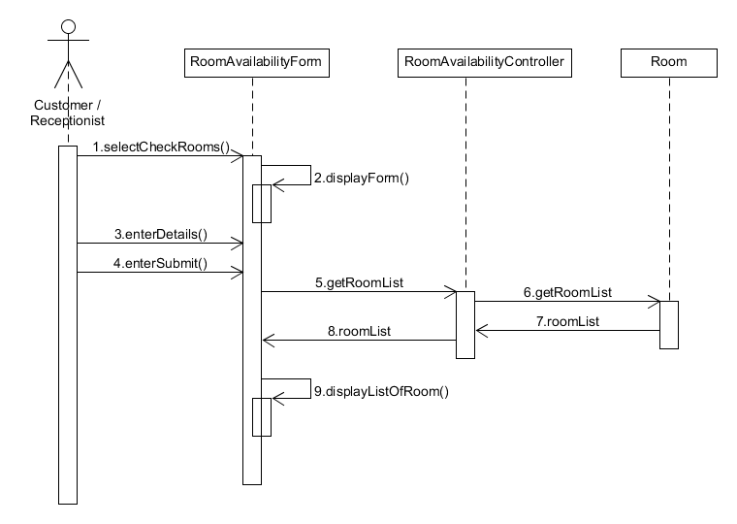

Figure 4: Booking Rooms

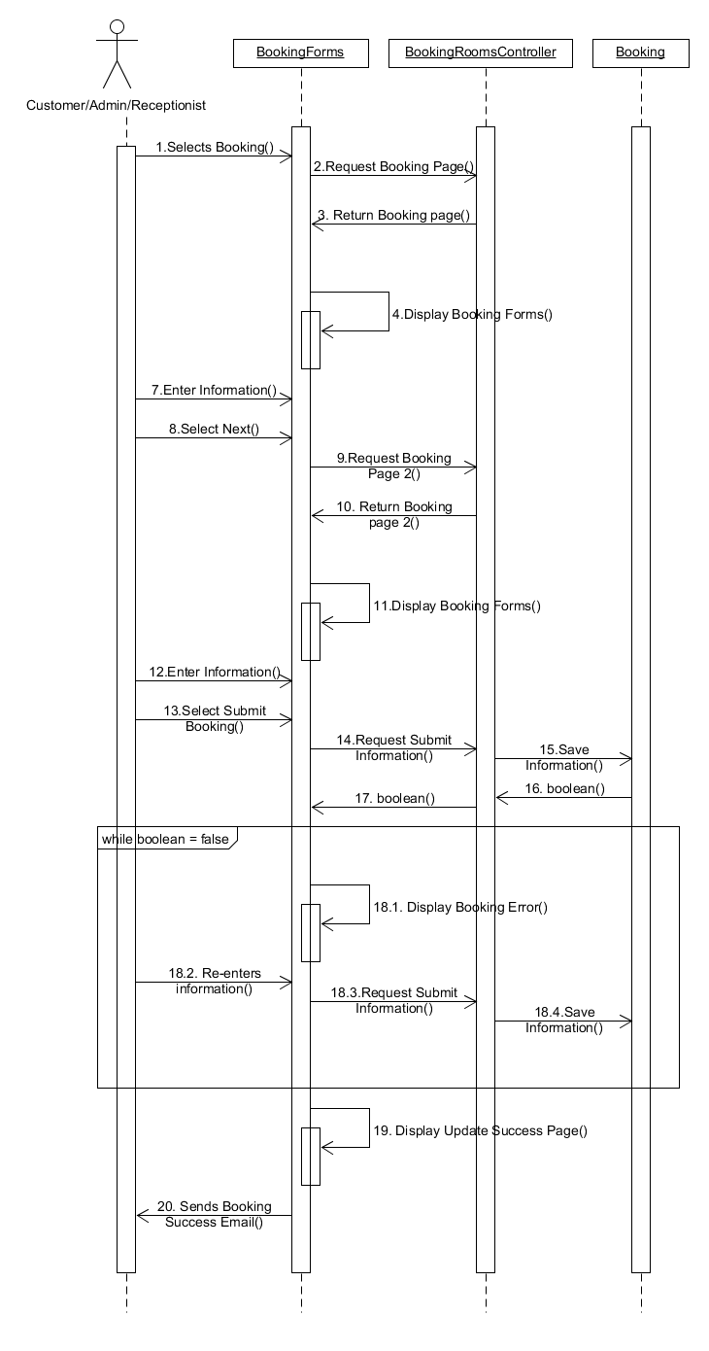

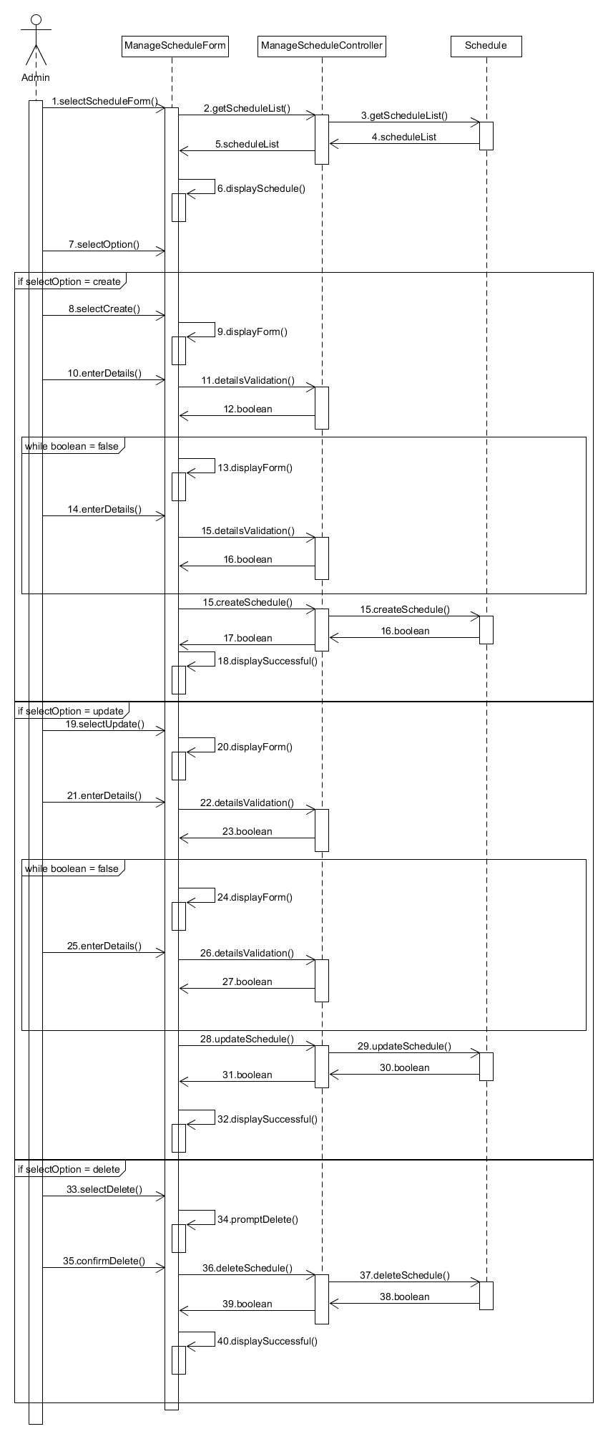

Figure 5: Housekeeping Management

Figure 6: Checking/Booking Facilities

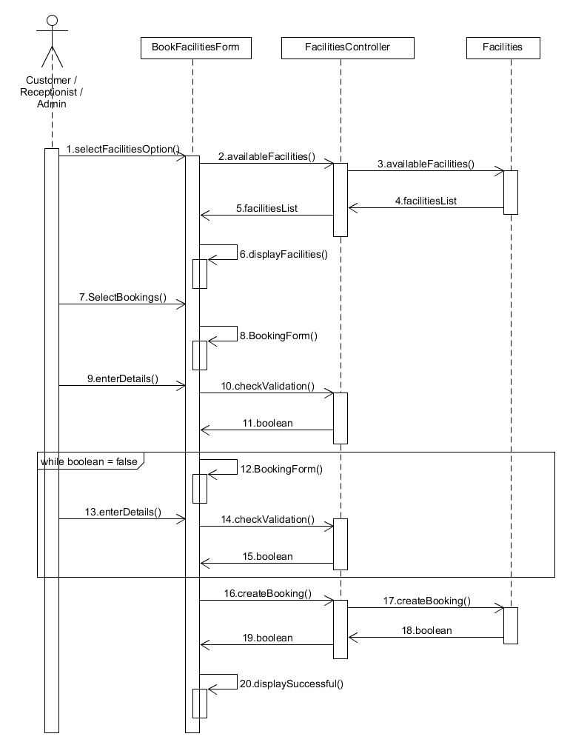

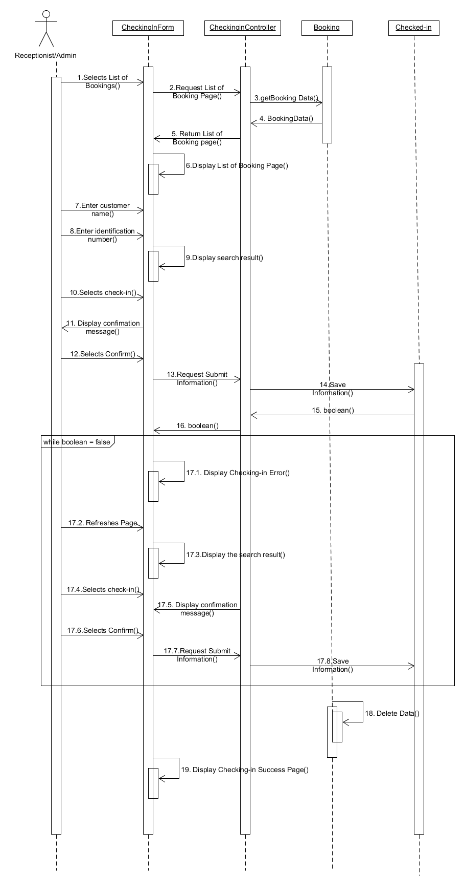

Figure 7: Check in hotel rooms

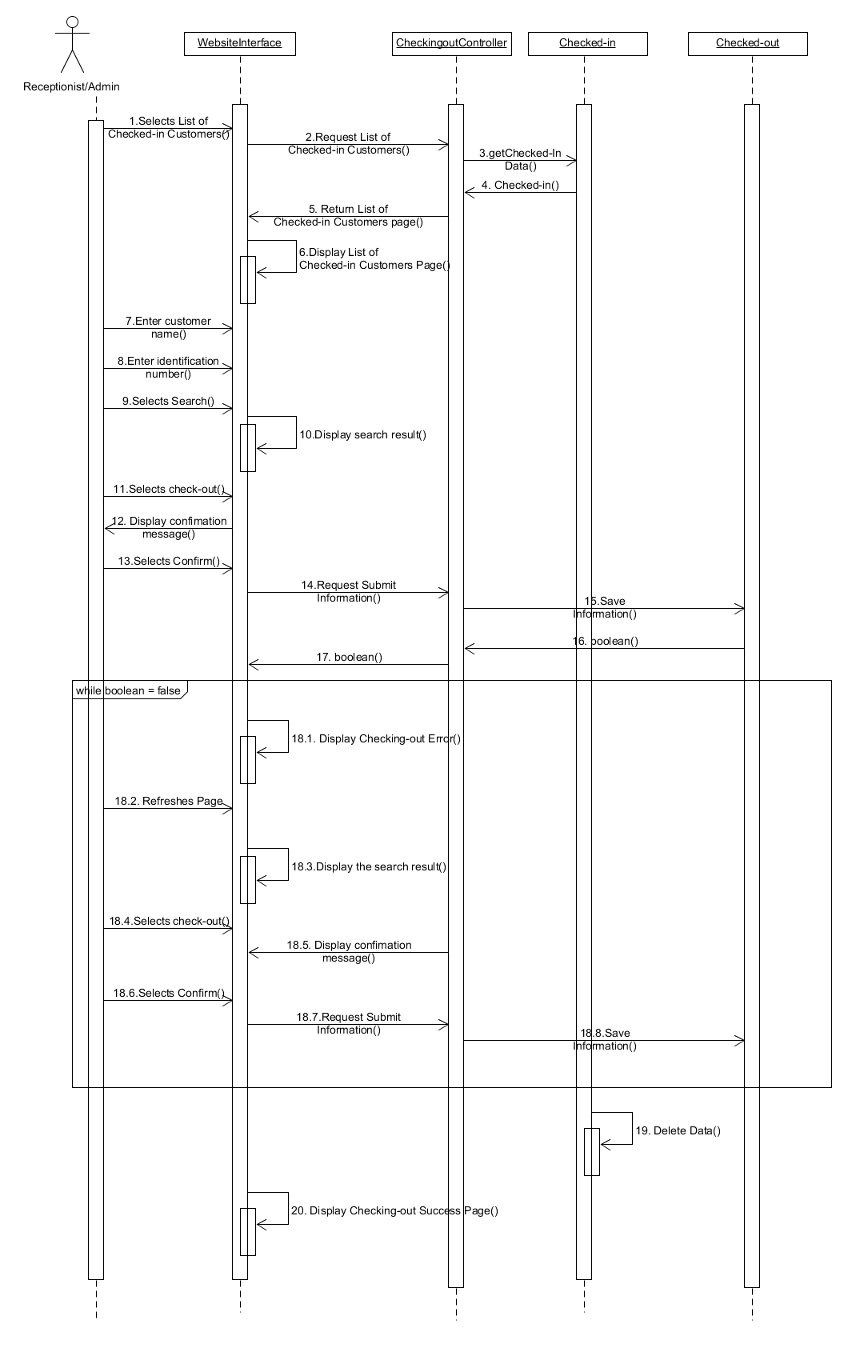

Figure 8: Check out hotel rooms

Figure 9: Check occupancy rate

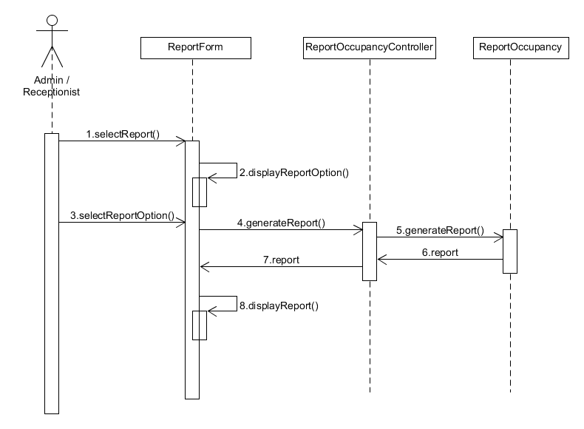

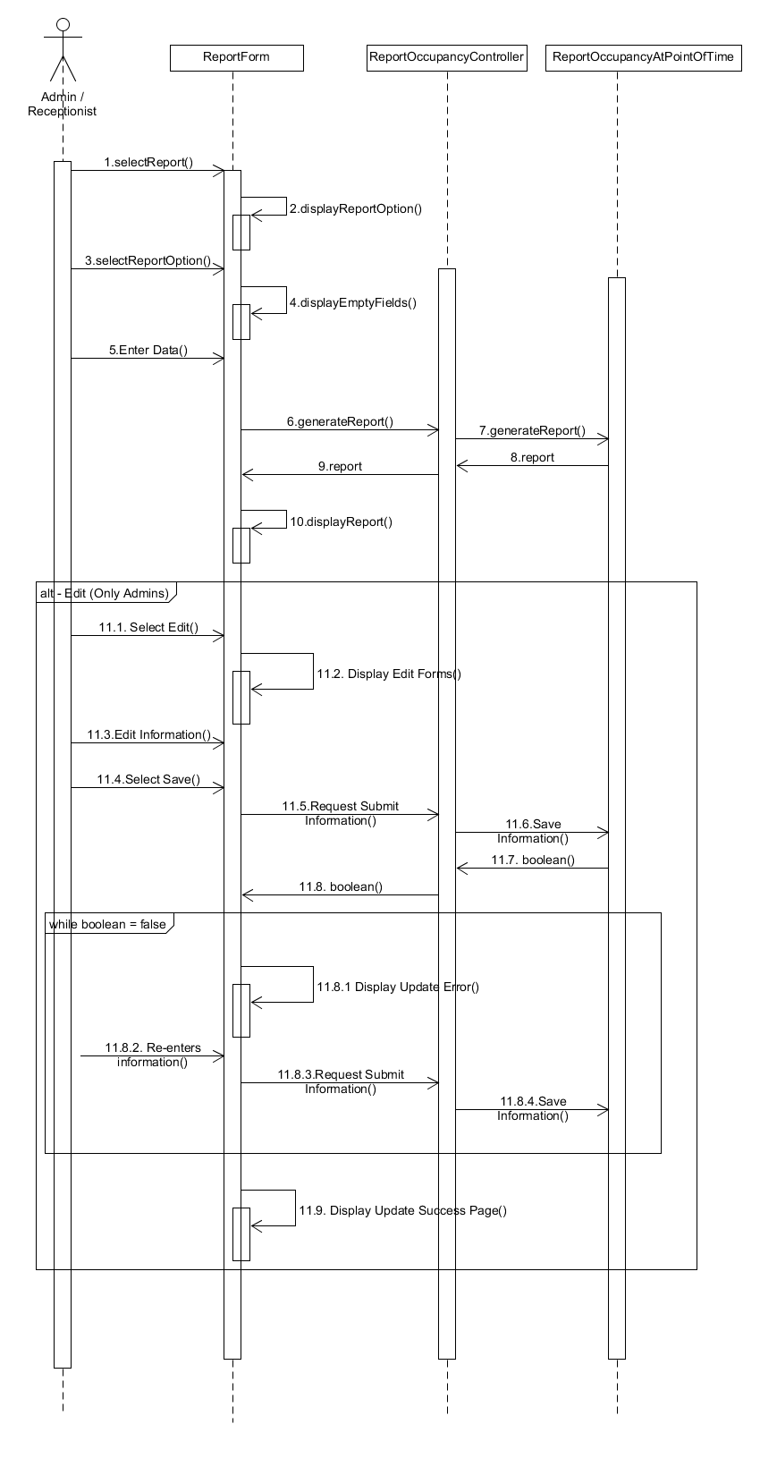

Figure 10: Report of occupancy rate at a point of time

Figure 11: Report of guest status

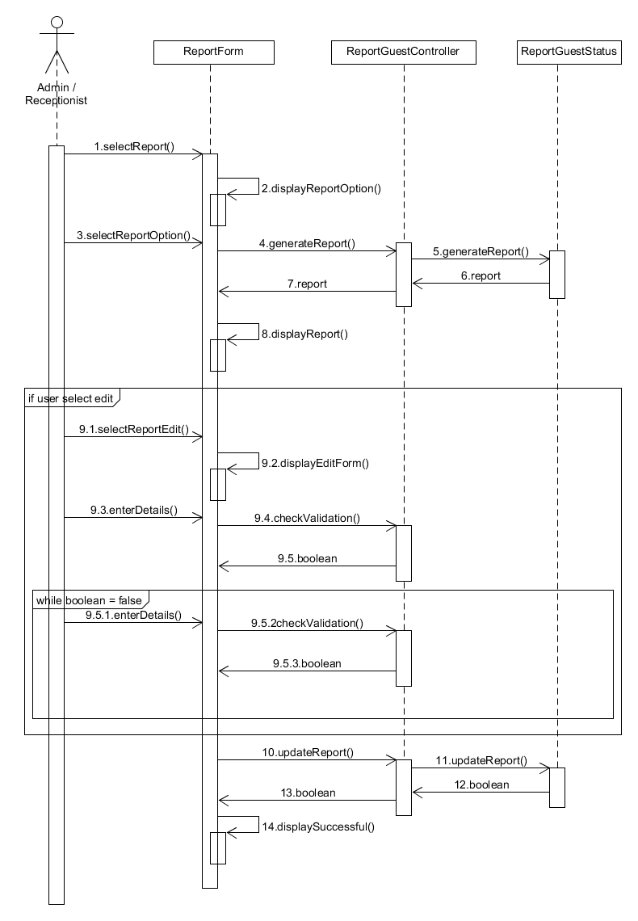

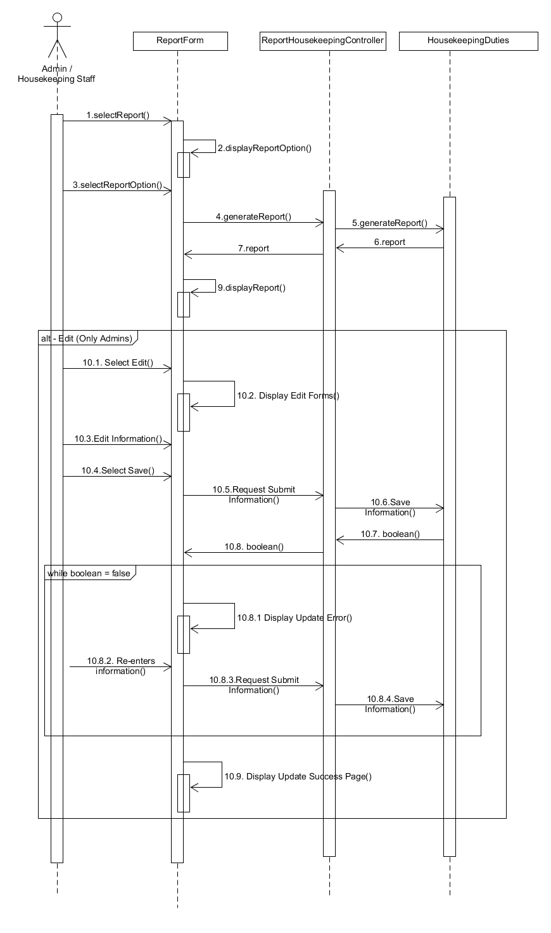Figure 13: Report of room status

Figure 12: Report of housekeeping duties



**VOPC Diagram**

Figure 1: Register

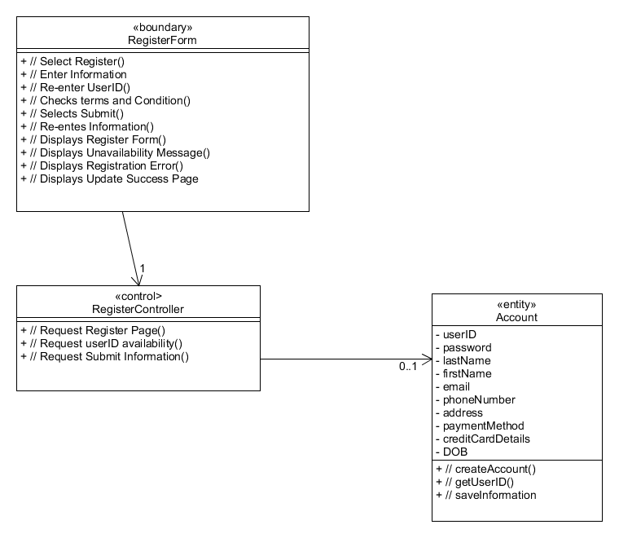

Figure 2: View/Update Profile

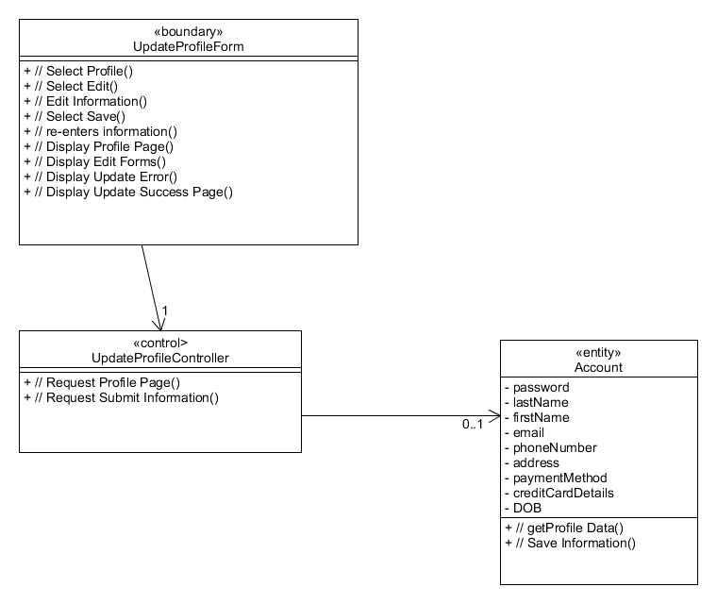

Figure 3: Checking Room Availability

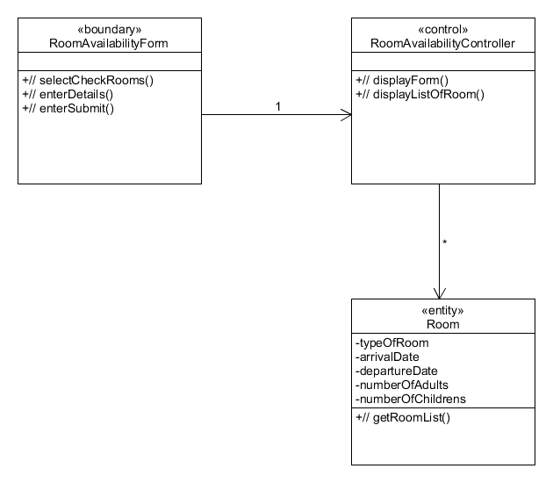

Figure 4: Booking Rooms

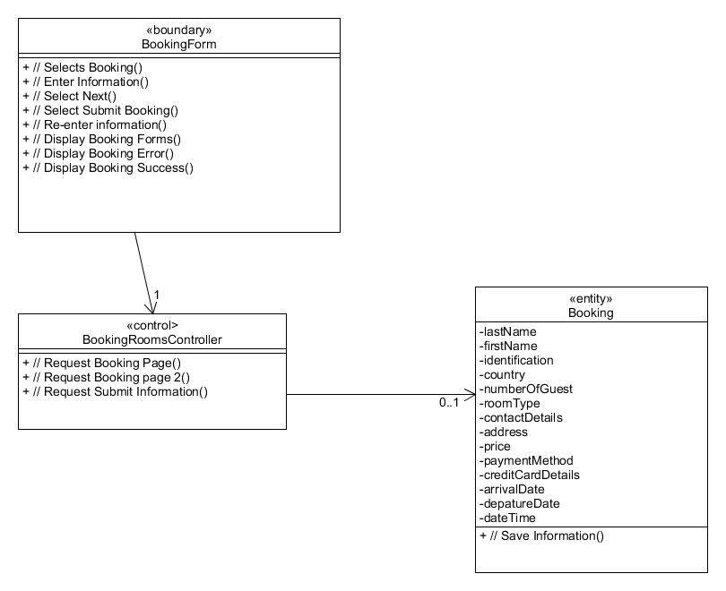

Figure 5: Housekeeping management

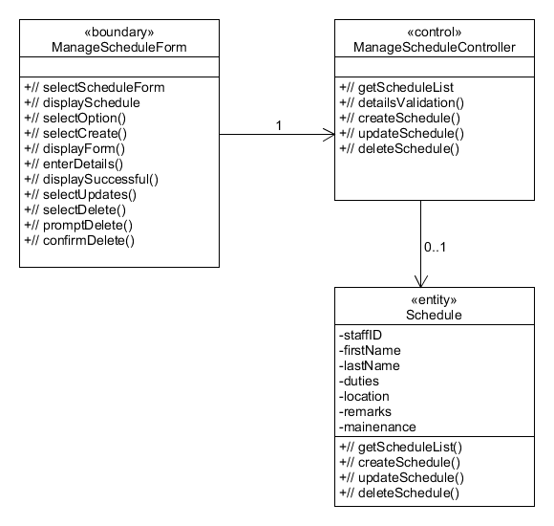

Figure 6: Booking Facilities

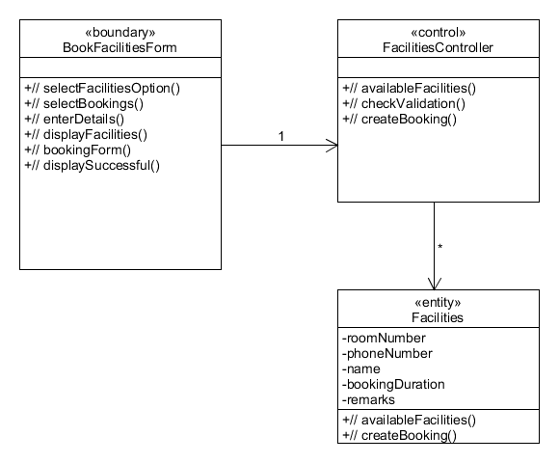

Figure 7: Check in hotel rooms

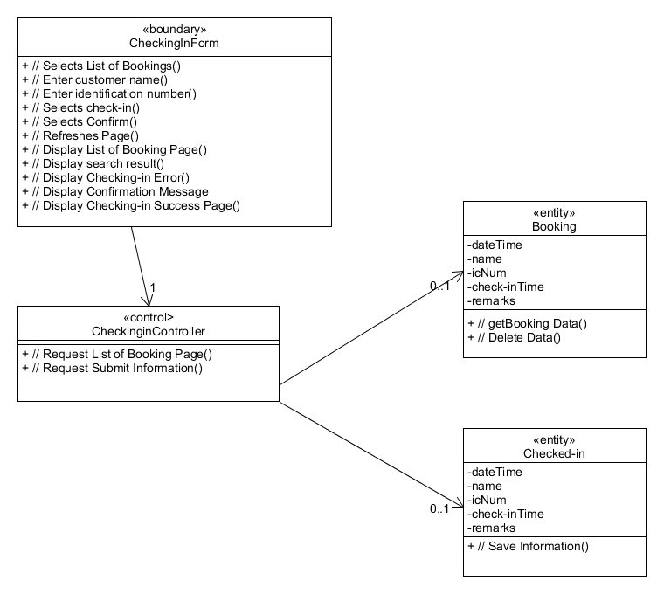

Figure 8: Check out hotel rooms

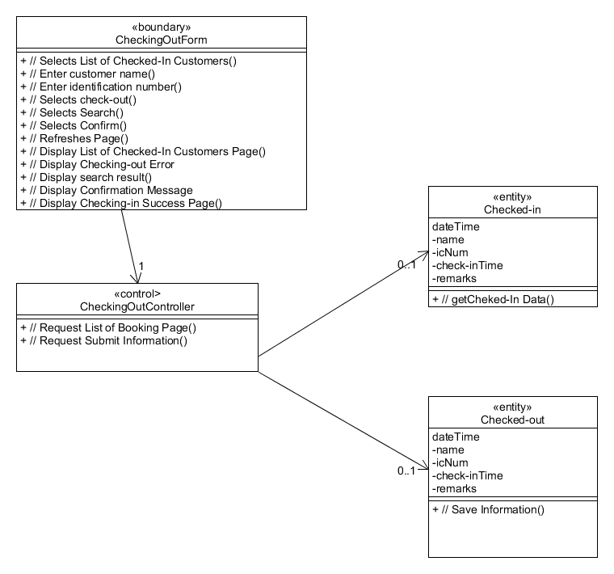

Figure 9: Check occupancy rate

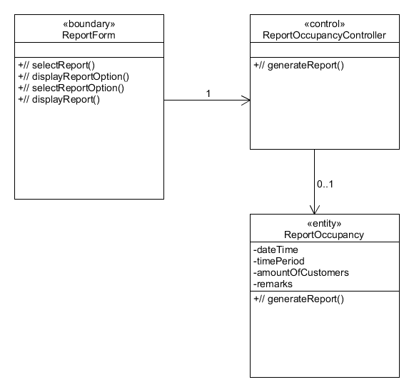

Figure 10: Report of occupancy rate at a point of time

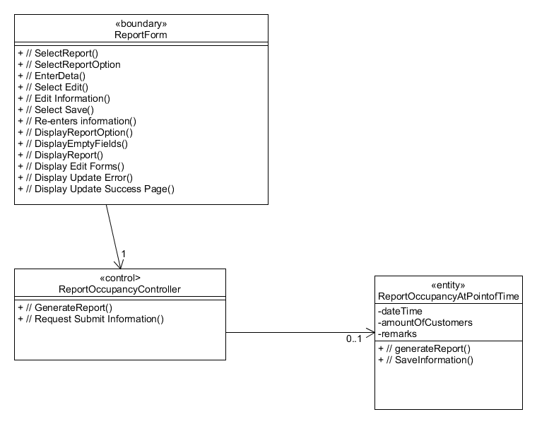

Figure 11: Report of guest status

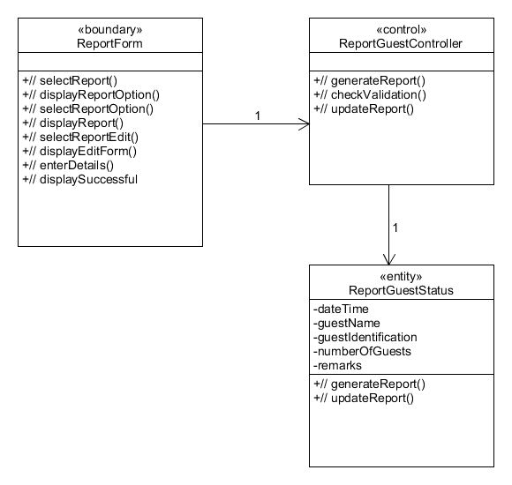

Figure 12: Report of housekeeping duties

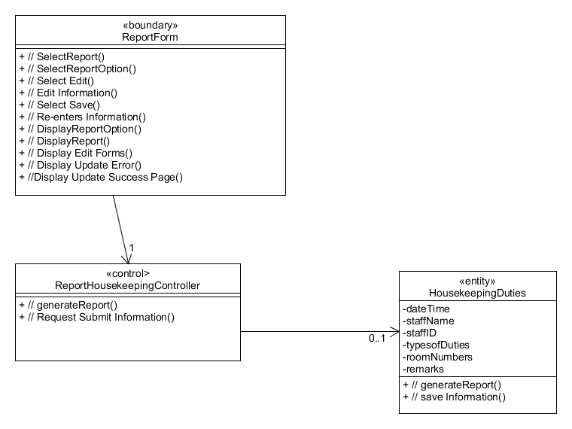

Figure 13: Report of room status

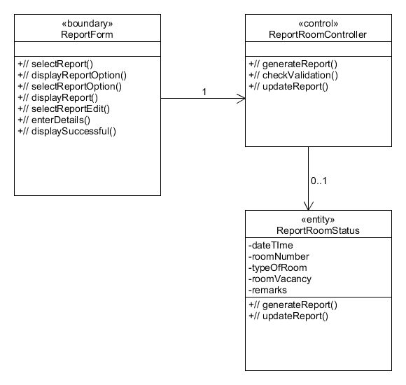

# 

# 

# 

# 

# **5.** **DATABASE DESIGN**

*[Document the database design. What considerations and decisions went into the design of the database schema? How does your database design solve your data storage requirements? Are there any limitations? Highlight portions of the database schema that needs explanation. Highlight also interesting/innovative portions of your database design.]*

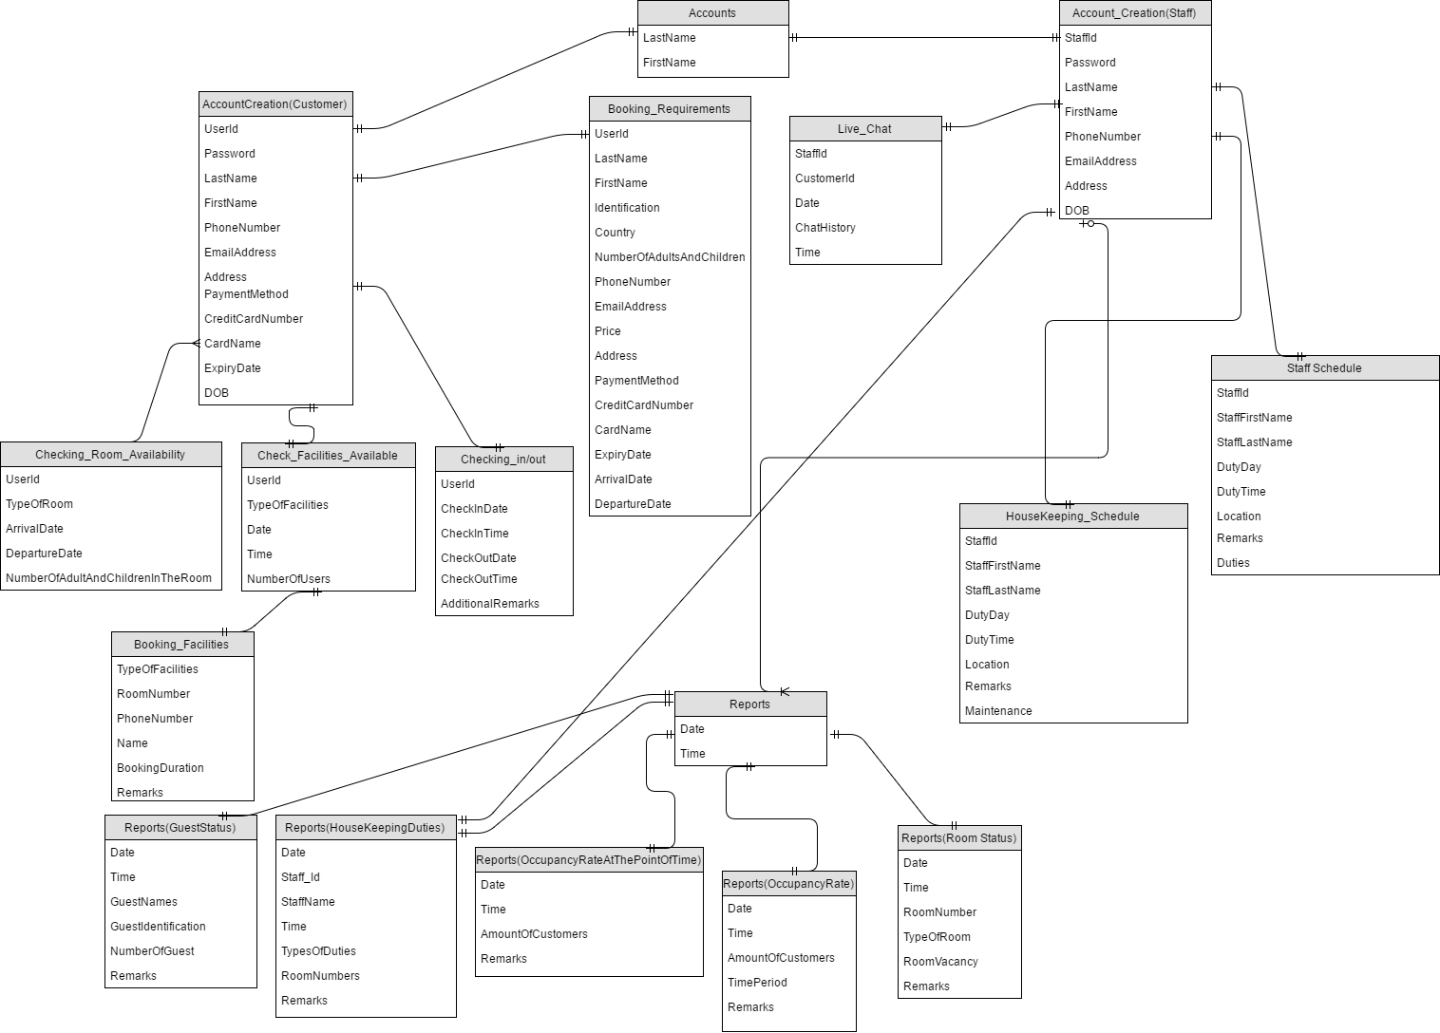

Table name:TB_Accounts

|  |  |  |  |  |  |
| --- | --- | --- | --- | --- | --- |
| Table Column name | Table Column Datatype | Table Column Null Option | Table Column Comment | Table Column is PK | Table Column is FK |
| FirstName | VARCHAR(30) | NOT NULL |  | Yes | Yes |
| LastName | VARCHAR(30) | NOT NULL |  | Yes | Yes |

Table name:TB_Reports

|  |  |  |  |  |  |
| --- | --- | --- | --- | --- | --- |
| Table Column name | Table Column Datatype | Table Column Null Option | Table Column Comment | Table Column is PK | Table Column is FK |
| Date | DATE | NOT NULL |  | Yes | Yes |
| Time | TIME | NOT NULL |  | Yes | Yes |

Table name:TB_AccountCreation(Customer)

|  |  |  |  |  |  |
| --- | --- | --- | --- | --- | --- |
| Table Column name | Table Column Datatype | Table Column Null Option | Table Column Comment | Table Column is PK | Table Column is FK |
| UserID | NUMBER(9) | NOT NULL |  | Yes | No |
| Password | VARCHAR(30) | NOT NULL |  | No | No |
| LastName | VARCHAR(30) | NOT NULL |  | Yes | Yes |
| FirstName | VARCHAR(30) | NOT NULL |  | Yes | Yes |
| PhoneNumber | NUMBER(15) | NOT NULL |  | No | No |
| EmailAddress | VARCHAR(30) | NOT NULL |  | No | No |
| Address | VARCHAR(100) | NOT NULL |  | No | No |
| PaymentMethod | VARCHAR(20) | NOT NULL |  | No | No |
| CreditCardNumber | NUMBER(20) | NULL | NOT NULL Only if payment method is by card | No | No |
| CardName | VARCHAR(30) | NULL | NOT NULL Only if payment method is by card | No | No |
| ExpiryDate | DATE | NULL | NOT NULL Only if payment method is by card | No | No |
| DOB | DATE | NOT NULL |  | No | No |

Table name:TB_BookingRequirements

|  |  |  |  |  |  |
| --- | --- | --- | --- | --- | --- |
| Table Column name | Table Column Datatype | Table Column Null Option | Table Column Comment | Table Column is PK | Table Column is FK |
| UserId | Number(9) | NOT NULL |  | Yes | Yes |
| LastName | VARCHAR(30) | NOT NULL |  | Yes | Yes |
| FirstName | VARCHAR(30) | NOT NULL |  | Yes | Yes |
| Identification | VARCHAR(20) | NOT NULL |  | No | No |
| Country | VARCHAR(20) | NOT NULL |  | No | No |
| NumberOfAdultsAndChildren | NUMBER(3) | NOT NULL |  | No | No |
| RoomType | VARCHAR(20) | NOT NULL |  | No | No |
| PhoneNumber | NUMBER(15) | NOT NULL |  | No | No |
| EmailAddress | VARCHAR(30) | NOT NULL |  | No | No |
| Price | NUMBER(10,2) | NOT NULL |  | No | No |
| Address | VARCHAR(100) | NOT NULL |  | No | No |
| PaymentMethod | VARCHAR(20) | NOT NULL |  | No | No |
| CreditCardNumber | NUMBER(20) | NULL | NOT NULL Only if payment method is by card | No | No |
| CardName | VARCHAR(30) | NULL | NOT NULL Only if payment method is by card | No | No |
| ExpiryDate | DATE | NULL | NOT NULL Only if payment method is by card | No | No |
| ArrivalDate | DATE | NOT NULL |  | No | No |
| DepartureDate | DATE | NOT NULL |  | No | No |

Table Name:TB_CheckingRoomAvailability

|  |  |  |  |  |  |
| --- | --- | --- | --- | --- | --- |
| Table Column name | Table Column Datatype | Table Column Null Option | Table Column Comment | Table Column is PK | Table Column is FK |
| UserId | Number(9) | NOT NULL |  | Yes | Yes |
| TypeOfRoom | VARCHAR(20) | NOT NULL |  | No | No |
| ArrivalDate | DATE | NOT NULL |  | No | No |
| DepartureDate | DATE | NOT NULL |  | No | No |
| NumberOfAdultsAndChildrenInTheRoom | NUMBER(3) | NOT NULL |  | No | No |

Table Name:TB_CheckFacilitiesAvailable

|  |  |  |  |  |  |
| --- | --- | --- | --- | --- | --- |
| Table Column name | Table Column Datatype | Table Column Null Option | Table Column Comment | Table Column is PK | Table Column is FK |
| UserId | Number(9) | NOT NULL |  | Yes | Yes |
| TypesOfFacilities | VARCHAR(30) | NOT NULL |  | Yes | No |
| Date | DATE | NOT NULL |  | No | No |
| Time | TIME | NOT NULL |  | No | No |
| NumberOfUsers | NUMBER(3) | NOT NULL |  | No | No |

Table Name:TB_BookingFacilities

|  |  |  |  |  |  |
| --- | --- | --- | --- | --- | --- |
| Table Column name | Table Column Datatype | Table Column Null Option | Table Column Comment | Table Column is PK | Table Column is FK |
| TypesOfFacilities | VARCHAR(30) | NOT NULL |  | Yes | Yes |
| RoomNumber | NUMBER(6) | NOT NULL |  | No | No |
| PhoneNumber | NUMBER(15) | NOT NULL |  | No | No |
| Name | VARCHAR(60) | NOT NULL |  | No | No |
| BookingDuration | NUMBER(1,2) | NOT NULL |  | No | No |
| Remarks | VARCHAR(50) | NULL |  | No | No |

Table Name:TB_CheckingIn/Out

|  |  |  |  |  |  |
| --- | --- | --- | --- | --- | --- |
| Table Column name | Table Column Datatype | Table Column Null Option | Table Column Comment | Table Column is PK | Table Column is FK |
| UserId | NUMBER(9) | NOT NULL |  | Yes | Yes |
| CheckInDate | DATE | NOT NULL |  | No | No |
| CheckInTime | TIME | NOT NULL |  | No | No |
| CheckOutDate | DATE | NOT NULL |  | No | No |
| CheckOutTime | TIME | NOT NULL |  | No | No |
| AdditionalRemarks | VARCHAR(50) | NULL |  | No | No |

Table Name:TB_AccountCreation(Staff)

|  |  |  |  |  |  |
| --- | --- | --- | --- | --- | --- |
| Table Column name | Table Column Datatype | Table Column Null Option | Table Column Comment | Table Column is PK | Table Column is FK |
| StaffId | NUMBER(9) | NOT NULL |  | Yes | No |
| Password | VARCHAR(30) | NOT NULL |  | No | No |
| LastName | VARCHAR(30) | NOT NULL |  | Yes | Yes |
| FirstName | VARCHAR(30) | NOT NULL |  | Yes | Yes |
| PhoneNumber | NUMBER(15) | NOT NULL |  | No | No |
| EmailAddress | VARCHAR(30) | NOT NULL |  | No | No |
| Address | VARCHAR(100) | NOT NULL |  | No | No |
| DOB | DATE | NOT NULL |  | No | No |

Table Name:TB_HousekeepingSchedule

|  |  |  |  |  |  |
| --- | --- | --- | --- | --- | --- |
| Table Column name | Table Column Datatype | Table Column Null Option | Table Column Comment | Table Column is PK | Table Column is FK |
| StaffId | NUMBER(9) | NOT NULL |  | Yes | Yes |
| StaffFirstName | VARCHAR(30) | NOT NULL |  | No | No |
| StaffLastName | VARCHAR(30) | NOT NULL |  | No | No |
| Date | DATE | NOT NULL |  | Yes | Yes |
| Time | TIME | NOT NULL |  | Yes | Yes |
| Location | VARCHAR(100) | NOT NULL |  | No | No |
| Remarks | VARCHAR(50) | NULL |  | No | No |
| Maintenance | VARCHAR(30) | NOT NULL |  | No | No |

Table Name:TB_StaffSchedule

|  |  |  |  |  |  |
| --- | --- | --- | --- | --- | --- |
| Table Column name | Table Column Datatype | Table Column Null Option | Table Column Comment | Table Column is PK | Table Column is FK |
| StaffId | NUMBER(9) | NOT NULL |  | Yes | Yes |
| StaffFirstName | VARCHAR(30) | NOT NULL |  | No | No |
| StaffLastName | VARCHAR(30) | NOT NULL |  | No | No |
| DutyDay | DATE | NOT NULL |  | No | No |
| DutyTime | TIME | NOT NULL |  | No | No |
| Location | VARCHAR(100) | NOT NULL |  | No | No |
| Remarks | VARCHAR(50) | NULL |  | No | No |
| Duties | VARCHAR(50) | NOT NULL |  | No | No |

Table Name:TB_Reports(GuestStatus)

|  |  |  |  |  |  |
| --- | --- | --- | --- | --- | --- |
| Table Column name | Table Column Datatype | Table Column Null Option | Table Column Comment | Table Column is PK | Table Column is FK |
| Date | DATE | NOT NULL |  | Yes | Yes |
| Time | TIME | NOT NULL |  | Yes | Yes |
| GuestNames | VARCHAR(200) | NOT NULL |  | No | No |
| GuestIdentification | VARCHAR(20) | NOT NULL |  | No | No |
| NumberOfGuest | Number(3) | NOT NULL |  | No | No |
| Remarks | VARCHAR(50) | NULL |  | No | No |

Table Name:TB_HousekeepingDuties

|  |  |  |  |  |  |
| --- | --- | --- | --- | --- | --- |
| Table Column name | Table Column Datatype | Table Column Null Option | Table Column Comment | Table Column is PK | Table Column is FK |
| Date | DATE | NOT NULL |  | No | No |
| StaffId | VARCHAR(9) | NOT NULL |  | Yes | Yes |
| StaffName | VARCHAR(60) | NOT NULL |  | No | No |
| Time | TIME | NOT NULL |  | No | No |
| TypesOfDuties | VARCHAR(100) | NOT NULL |  | No | No |
| RoomNumbers | VARCHAR(20) | NOT NULL |  | No | No |
| Remarks | VARCHAR(50) | NULL |  | No | No |

Table Name:TB_Reports(OccupancyRateAtThePointOfTime)

|  |  |  |  |  |  |
| --- | --- | --- | --- | --- | --- |
| Table Column name | Table Column Datatype | Table Column Null Option | Table Column Comment | Table Column is PK | Table Column is FK |
| Date | DATE | NOT NULL |  | Yes | Yes |
| Time | TIME | NOT NULL |  | Yes | Yes |
| AmountOfCustomers | NUMBER(9) | NOT NULL |  | No | No |
| Remarks | VARCHAR(50) | NULL |  | No | No |

Table Name:TB_Reports(OccupancyRate)

|  |  |  |  |  |  |
| --- | --- | --- | --- | --- | --- |
| Table Column name | Table Column Datatype | Table Column Null Option | Table Column Comment | Table Column is PK | Table Column is FK |
| Date | DATE | NOT NULL |  | Yes | Yes |
| Time | TIME | NOT NULL |  | Yes | Yes |
| AmountOfCustomers | NUMBER(3) | NOT NULL |  | No | No |
| TimePeriod | NUMBER(10,2) | NOT NULL |  | No | No |
| Remarks | VARCHAR(50) | NULL |  | No | No |

Table Name:TB_RoomStatus

|  |  |  |  |  |  |
| --- | --- | --- | --- | --- | --- |
| Table Column name | Table Column Datatype | Table Column Null Option | Table Column Comment | Table Column is PK | Table Column is FK |
| Date | DATE | NOT NULL |  | Yes | Yes |
| Time | TIME | NOT NULL |  | Yes | Yes |
| RoomNumber | NUMBER(20) | NOT NULL |  | No | No |
| TypeOfRoom | VARCHAR(20) | NOT NULL |  | No | No |
| RoomVacancy | VARCHAR(12) | NOT NULL |  | No | No |
| Remarks | VARCHAR(50) | NULL |  | No | No |